TERMPROJECT

(CS-779 Advance Database Management)

Electronic Store Datawarehouse Project

Table of Contents

Introduction………………………………………………………………………………………………3

ERD Diagram……………………………………………………………………………………………...4

Code………………………………………………………………………………………………………….5

Star Schema………………………………………………………………………………………………7

Code………………………………………………………………………………………………………….9

Power BI Visualization………………………………………………………………………………15

Python to clean Data ……………………………………………………………………………….18

Inserting Data to existing tables………………………………………………………………28

Testing…………………………………………………………………………………………………….97

Slow Changing Dimensions……………………………………………………………………….103

Conclusion………………………………………………………………………………………………...105

Bibliography ……………………………………………………………………………………………... 105

Introduction

The ever-evolving landscape of electronic retail demands robust and efficient data management systems to support critical business operations and insightful decision-making. In response to this need, our project embarks on the design and development of a comprehensive database for an electronic store, laying the foundation for a streamlined and analytics-ready information architecture.

**1. Data Cleaning**

In the initial phase, we diligently address the intricacies of raw data, employing rigorous data cleaning techniques to rectify inconsistencies, eliminate errors, and standardize formats. Our objective is to ensure the integrity and quality of the data, laying the groundwork for subsequent phases of the project.

**2. Normalization**

Building on the principles of database normalization, we structure the dataset to adhere to higher standards of organization and reduce redundancy. This involves breaking down tables into smaller, related entities, achieving a clean and logically structured database schema. The normalization process follows recognized forms such as 1NF, 2NF, and 3NF to create a robust and efficient data model.

**3. ERD Design**

With a normalized dataset in hand, we proceed to design an Entity-Relationship Diagram (ERD). This visual representation captures the entities, relationships, attributes, and keys essential to the electronic store's operational and analytical aspects. The ERD serves as a blueprint for the subsequent stages of database development.

**4. Data Warehouse Modeling**

Taking a strategic leap toward business intelligence and analytics, we transform the normalized ERD into a data warehouse model. The star schema architecture is adopted, featuring dimension tables for descriptive attributes and fact tables for measurable, numeric data.

ERD Diagram

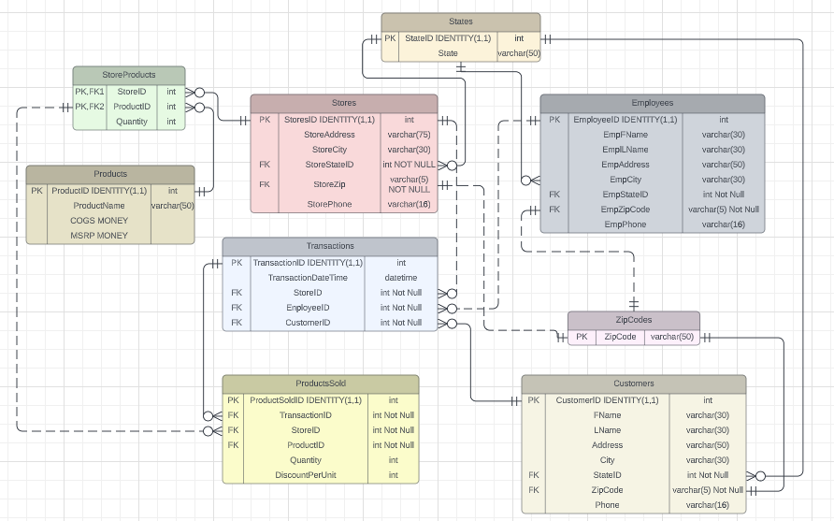

Code to create tables:

--Creating the States Table

CREATE TABLE States (

StateId INT PRIMARY KEY IDENTITY(1,1),

State VARCHAR(2)

);

--Creating the ZipCodes Table

CREATE TABLE ZipCodes (

ZipCode VARCHAR(5) PRIMARY KEY

);

--Creating the Employees Table

CREATE TABLE Employees (

EmployeeId INT PRIMARY KEY IDENTITY(1,1),

EmpFName VARCHAR(30),

EmpLName VARCHAR(30),

EmpAddress VARCHAR(50),

EmpCity VARCHAR(30),

EmpState INT REFERENCES States(StateId) NOT NULL,

EmpZipCode VARCHAR(5) REFERENCES ZipCodes(ZipCode) NOT NULL,

EmpPhone VARCHAR(16)

);

--Creating the Customers Table

CREATE TABLE Customers (

CustomerId INT PRIMARY KEY IDENTITY(1,1),

FName VARCHAR(30),

LName VARCHAR(30),

Address VARCHAR(50),

City VARCHAR(30),

State INT REFERENCES States(StateId) NOT NULL,

ZipCode VARCHAR(5) REFERENCES ZipCodes(ZipCode) NOT NULL,

Phone VARCHAR(16)

);

-- Creating the Stores Table

CREATE TABLE Stores (

StoreId INT PRIMARY KEY IDENTITY(1,1),

StoreAddress VARCHAR(75),

StoreCity VARCHAR(30),

StoreStateID INT REFERENCES States(StateID) NOT NULL,

StoreZip VARCHAR(5) REFERENCES ZipCodes(ZipCode) NOT NULL,

StorePhone VARCHAR(16)

);

-- Creating the Transactions Table

CREATE TABLE Transactions (

TransactionID INT PRIMARY KEY IDENTITY(1,1),

TransactionDateTime DATETIME,

StoreID INT REFERENCES Stores(StoreID) NOT NULL,

EmployeeID INT REFERENCES Employees(EmployeeID) NOT NULL,

CustomerID INT REFERENCES Customers(CustomerID) NOT NULL

);

-- Creating the Products Table

CREATE TABLE Products (

ProductID INT PRIMARY KEY IDENTITY(1,1),

ProductName VARCHAR(50),

COGS MONEY,

MSRP MONEY

);

-- Creating the StoreProducts Table

CREATE TABLE StoreProducts (

StoreID INT REFERENCES Stores(StoreID) NOT NULL,

ProductID INT REFERENCES Products(ProductID) NOT NULL,

Quantity INT,

PRIMARY KEY (StoreID, ProductID)

);

--Creating the ProductsSold Table

CREATE TABLE ProductsSold (

ProductSoldID INT PRIMARY KEY IDENTITY(1,1),

TransactionID INT REFERENCES Transactions(TransactionID) NOT NULL,

Quantity INT,

DiscountPerUnit MONEY,

StoreID INT NOT NULL,

ProductID INT NOT NULL,

FOREIGN KEY (StoreID, ProductID) REFERENCES StoreProducts(StoreID, ProductID)

);

Star Schema

Star Schema with LucidChart:

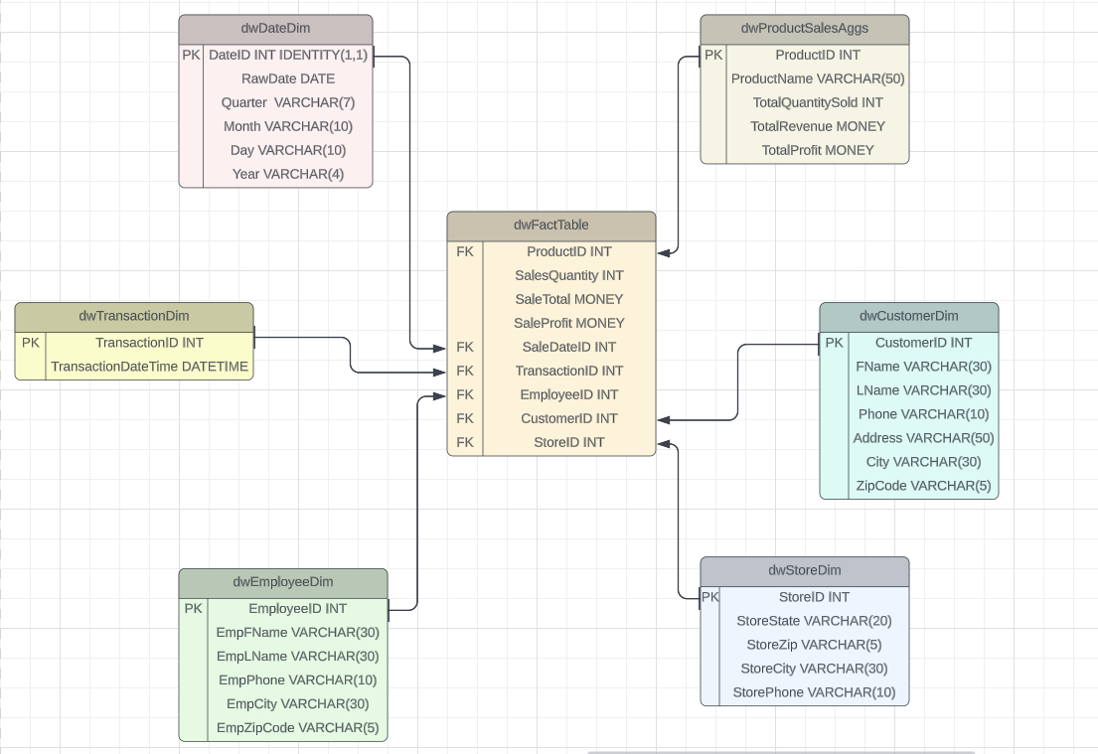

Star Schema with Power BI:

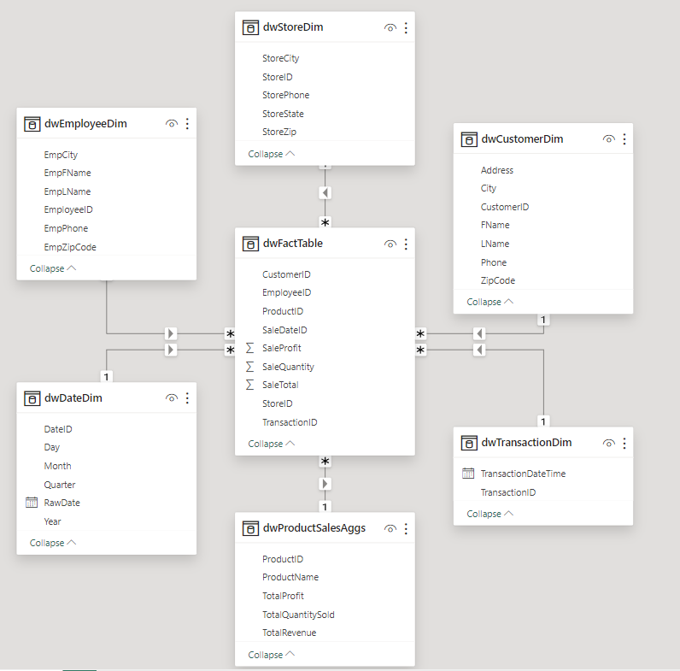

Code to create tables for star Schema:

-- Creating Dimension Table and a Fact Table for Star Schema

--Creating the dwProductSalesAggs Table

CREATE TABLE dwProductSalesAggs (

ProductID INT PRIMARY KEY,

ProductName VARCHAR(50),

TotalQuantitySold INT,

TotalRevenue MONEY,

TotalProfit MONEY

);

--Creating the dwStoreDim Table

CREATE TABLE dwStoreDim (

StoreID INT PRIMARY KEY,

StoreState VARCHAR(2),

StoreZip VARCHAR(5),

StoreCity VARCHAR(30),

StorePhone VARCHAR(10)

);

--Creating the dwDateDim Table

CREATE TABLE dwDateDim (

DateID INT PRIMARY KEY IDENTITY(1,1),

RawDate DATE,

Quarter VARCHAR(7),

Month VARCHAR(10),

Day VARCHAR(10),

Year VARCHAR(4)

);

--Creating the dwEmployeeDim Table

CREATE TABLE dwEmployeeDim (

EmployeeID INT PRIMARY KEY IDENTITY(1,1),

EmpFName VARCHAR(30),

EmpLName VARCHAR(30),

EmpPhone VARCHAR(10),

EmpCity VARCHAR(30),

EmpZipCode VARCHAR(5)

);

--Creating the dwTransactionDim Table

CREATE TABLE dwTransactionDim (

TransactionID INT PRIMARY KEY IDENTITY(1,1),

TransactionDateTime DATETIME

);

--Creating the dwCustomerDim Table

CREATE TABLE dwCustomerDim (

CustomerID INT PRIMARY KEY IDENTITY(1,1),

FName VARCHAR(30),

LName VARCHAR(30),

Phone Varchar(10),

Address VARCHAR(50),

City VARCHAR(30),

ZipCode VARCHAR(5)

);

--Creating the dwFactTable

CREATE TABLE dwFactTable (

ProductID INT REFERENCES dwProductSalesAggs(ProductID),

SaleQuantity INT,

SaleTotal MONEY,

SaleProfit MONEY,

SaleDateID INT REFERENCES dwDateDim(DateID),

TransactionID INT REFERENCES dwTransactionDim(TransactionID),

EmployeeID INT REFERENCES dwEmployeeDim(EmployeeID),

CustomerID INT REFERENCES dwCustomerDim(CustomerID),

StoreID INT REFERENCES dwStoreDim(StoreID)

);

Code to populate Star Schema:

-- Populating dwDateDim

CREATE PROC PopulateDateDim

(@vStartDate DATE, @vEndDate DATE)

AS

BEGIN

WHILE @vStartDate <= @vEndDate

BEGIN

INSERT INTO dwDateDim

VALUES (

@vStartDate,

CONCAT('Q', DATEPART(QUARTER, @vStartDate), ' ', DATEPART(YEAR, @vStartDate)),

DATENAME(MONTH, @vStartDate),

DATENAME(WEEKDAY, @vStartDate),

DATENAME(YEAR, @vStartDate)

)

SET @vStartDate = DATEADD(DAY, 1, @vStartDate)

END

END;

-- Populating dwStoreDim

CREATE PROC PopulateStoreDim

AS

BEGIN

DECLARE @vStore INT, @vStop INT

-- Insert new records into dwStoreDim

INSERT INTO dwStoreDim (StoreID, StoreState, StoreZip, StoreCity, StorePhone)

SELECT a.StoreID, b.State, a.StoreZip, a.StoreCity, a.StorePhone

FROM Stores a

JOIN States b ON a.StoreStateID = b.StateID

WHERE a.StoreID NOT IN (SELECT StoreID FROM dwStoreDim)

-- Get the minimum and maximum StoreID

SELECT @vStore = MIN(StoreID), @vStop = MAX(StoreID)

FROM Stores

-- Update existing records in dwStoreDim

WHILE @vStore <= @vStop

BEGIN

UPDATE dwStoreDim

SET StoreState = (SELECT State FROM Stores s JOIN States st

ON s.StoreStateID = st.StateID WHERE s.StoreID = @vStore),

StoreZip = (SELECT StoreZip FROM Stores WHERE StoreID = @vStore),

StoreCity = (SELECT StoreCity FROM Stores WHERE StoreID = @vStore),

StorePhone = (SELECT StorePhone FROM Stores WHERE StoreID = @vStore)

WHERE StoreID = @vStore

-- Get the next StoreID

SELECT @vStore = MIN(StoreID)

FROM Stores

WHERE StoreID > @vStore

END

END;

-- Populating dwEmployeeDim

CREATE PROC PopulateEmployeeDim

AS

BEGIN

DECLARE @vEmployee INT, @vStop INT

-- Insert new records into dwEmployeeDim

INSERT INTO dwEmployeeDim (EmpFName, EmpLName, EmpPhone, EmpCity, EmpZipCode)

SELECT e.EmpFName, e.EmpLName, e.EmpPhone, e.EmpCity, e.EmpZipCode

FROM Employees e

WHERE e.EmployeeID NOT IN (SELECT EmployeeID FROM dwEmployeeDim)

-- Get the minimum and maximum EmployeeID

SELECT @vEmployee = MIN(EmployeeID), @vStop = MAX(EmployeeID)

FROM Employees

-- Update existing records in dwEmployeeDim

WHILE @vEmployee <= @vStop

BEGIN

UPDATE dwEmployeeDim

SET EmpFName = (SELECT EmpFName FROM Employees WHERE EmployeeID = @vEmployee),

EmpLName = (SELECT EmpLName FROM Employees WHERE EmployeeID = @vEmployee),

EmpPhone = (SELECT EmpPhone FROM Employees WHERE EmployeeID = @vEmployee),

EmpCity = (SELECT EmpCity FROM Employees WHERE EmployeeID = @vEmployee),

EmpZipCode = (SELECT EmpZipCode FROM Employees WHERE EmployeeID = @vEmployee)

WHERE EmployeeID = @vEmployee

-- Get the next EmployeeID

SELECT @vEmployee = MIN(EmployeeID)

FROM Employees

WHERE EmployeeID > @vEmployee

END

END;

-- Populating dwCustomerDim

CREATE PROC PopulateCustomerDim

AS

BEGIN

DECLARE @vCustomer INT, @vStop INT

-- Insert new records into dwCustomerDim

INSERT INTO dwCustomerDim (FName, LName, Phone, Address, City, ZipCode)

SELECT c.FName, c.LName, c.Phone, c.Address, c.City, c.ZipCode

FROM Customers c

WHERE c.CustomerID NOT IN (SELECT CustomerID FROM dwCustomerDim)

-- Get the minimum and maximum CustomerID

SELECT @vCustomer = MIN(CustomerID), @vStop = MAX(CustomerID)

FROM Customers

-- Update existing records in dwCustomerDim

WHILE @vCustomer <= @vStop

BEGIN

UPDATE dwCustomerDim

SET FName = (SELECT FName FROM Customers WHERE CustomerID = @vCustomer),

LName = (SELECT LName FROM Customers WHERE CustomerID = @vCustomer),

Phone = (SELECT Phone FROM Customers WHERE CustomerID = @vCustomer),

Address = (SELECT Address FROM Customers WHERE CustomerID = @vCustomer),

City = (SELECT City FROM Customers WHERE CustomerID = @vCustomer),

ZipCode = (SELECT ZipCode FROM Customers WHERE CustomerID = @vCustomer)

WHERE CustomerID = @vCustomer

-- Get the next CustomerID

SELECT @vCustomer = MIN(CustomerID)

FROM Customers

WHERE CustomerID > @vCustomer

END

END;

-- Populating dwTransactionDim

CREATE PROC PopulateTransactionDim

AS

BEGIN

-- Insert new records into dwTransactionDim

INSERT INTO dwTransactionDim (TransactionDateTime)

SELECT t.TransactionDateTime

FROM Transactions t

WHERE t.TransactionID NOT IN (SELECT TransactionID FROM dwTransactionDim)

END;

CREATE PROC PopulateProductSalesAggs

AS

BEGIN

-- Insert new records into dwProductSalesAggs

INSERT INTO dwProductSalesAggs (ProductID, ProductName, TotalQuantitySold, TotalRevenue, TotalProfit)

SELECT

a.ProductID,

a.ProductName,

SUM(b.Quantity) AS TotalQuantity,

SUM(b.Quantity * a.MSRP) AS TotalRev,

SUM((b.Quantity * a.MSRP) - (b.Quantity * b.DiscountPerUnit) - (a.COGS * b.Quantity)) AS TotalProfit

FROM

Products a

LEFT JOIN ProductsSold b ON a.ProductID = b.ProductID

GROUP BY a.ProductID, a.ProductName;

-- Update existing records in dwProductSalesAggs

UPDATE p

SET

ProductName = s.ProductName,

TotalQuantitySold = s.TotalQuantity,

TotalRevenue = s.TotalRev,

TotalProfit = s.TotalProfit

FROM dwProductSalesAggs p

INNER JOIN (

SELECT

a.ProductID,

a.ProductName,

SUM(b.Quantity) AS TotalQuantity,

SUM(b.Quantity * a.MSRP) AS TotalRev,

SUM((b.Quantity * a.MSRP) - (b.Quantity * b.DiscountPerUnit) - (a.COGS * b.Quantity)) AS TotalProfit

FROM

Products a

LEFT JOIN ProductsSold b ON a.ProductID = b.ProductID

GROUP BY a.ProductID, a.ProductName

) AS s ON p.ProductID = s.ProductID;

END;

CREATE PROC PopulateFactTable

AS

BEGIN

TRUNCATE TABLE dwFactTable;

INSERT INTO dwFactTable

SELECT

a.ProductID,

a.Quantity,

(b.MSRP * a.Quantity),

(b.MSRP * a.Quantity) - (a.Quantity * a.DiscountPerUnit),

d.DateID,

c.TransactionID,

c.EmployeeID,

c.CustomerID,

c.StoreID

FROM

ProductsSold a

JOIN Products b ON a.ProductID = b.ProductID

JOIN Transactions c ON a.TransactionID = c.TransactionID

JOIN dwDateDim d ON CAST(c.TransactionDateTime AS DATE) = d.RawDate

END;

-- Executing the Stored Procedures to populate the Data Warehouse

DECLARE @StartDate DATE = '2013-01-01';

DECLARE @EndDate DATE = '2028-12-31';

-- Ensure that the date dimension is populated first

EXEC PopulateDateDim @vStartDate = @StartDate, @vEndDate = @EndDate;

-- Now execute other procedures

EXEC PopulateStoreDim;

EXEC PopulateEmployeeDim;

EXEC PopulateCustomerDim;

EXEC PopulateTransactionDim;

EXEC PopulateProductSalesAggs;

EXEC PopulateFactTable;

select* from[dbo].[dwCustomerDim]

select* from[dbo].[dwDateDim]

select* from[dbo].[dwEmployeeDim]

select* from[dbo].[dwFactTable]

select* from[dbo].[dwProductSalesAggs]

select* from[dbo].[dwStoreDim]

select* from[dbo].[dwTransactionDim]

Power BI Visualizations:

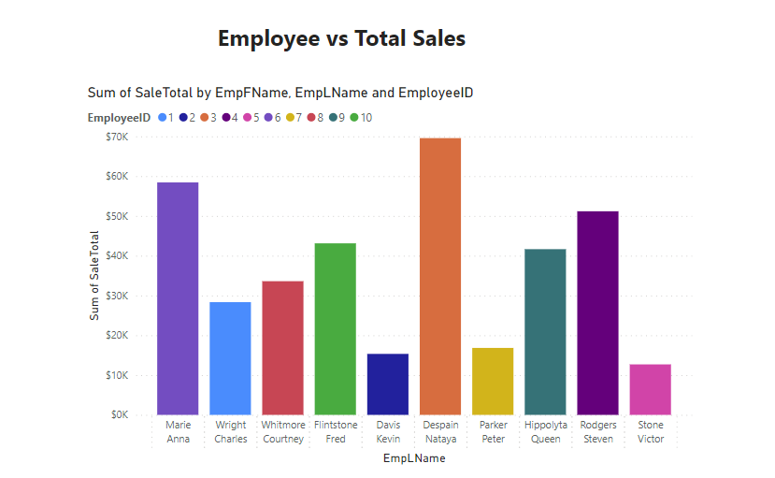

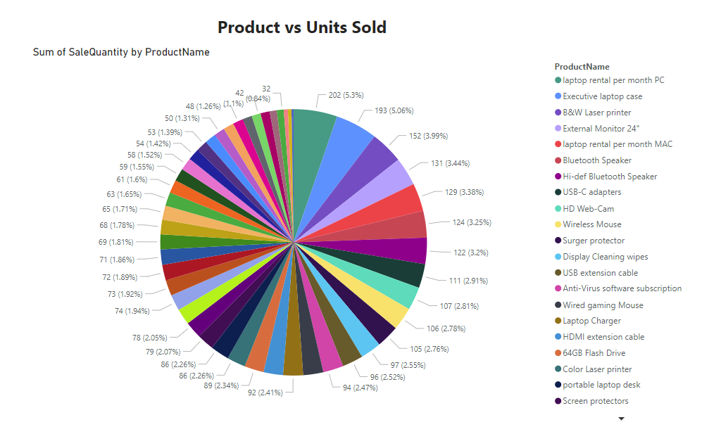

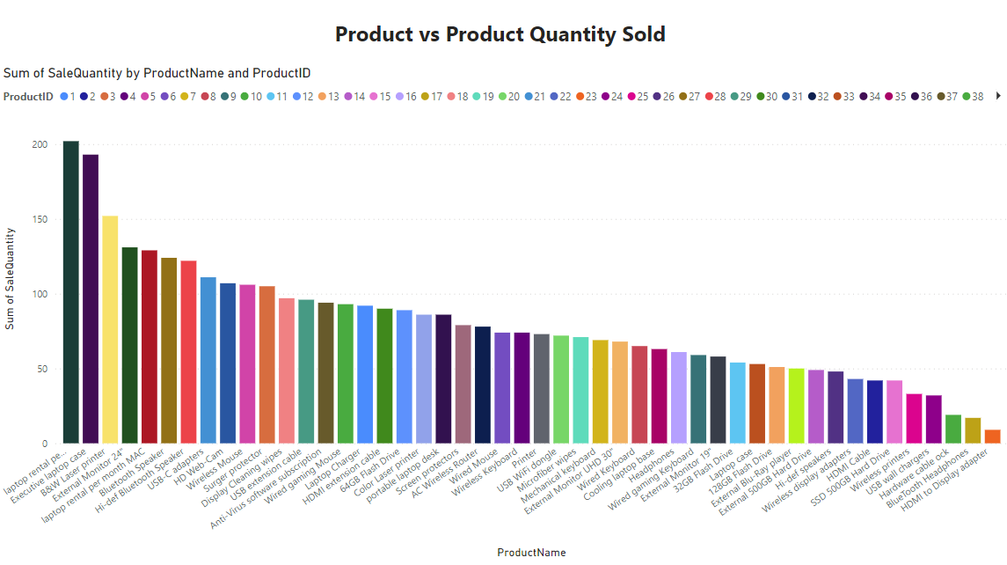

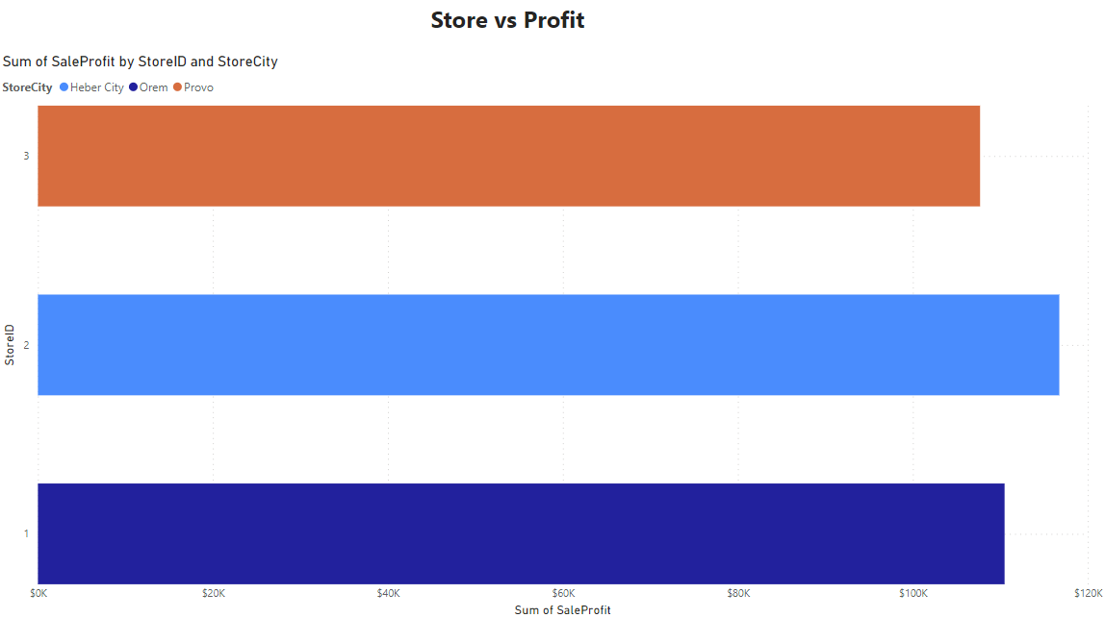

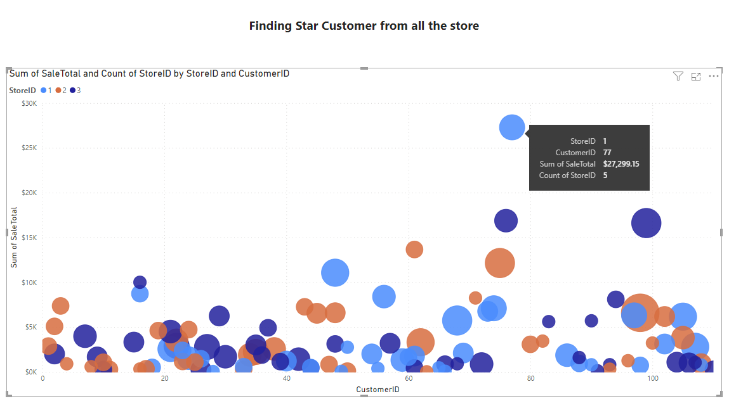

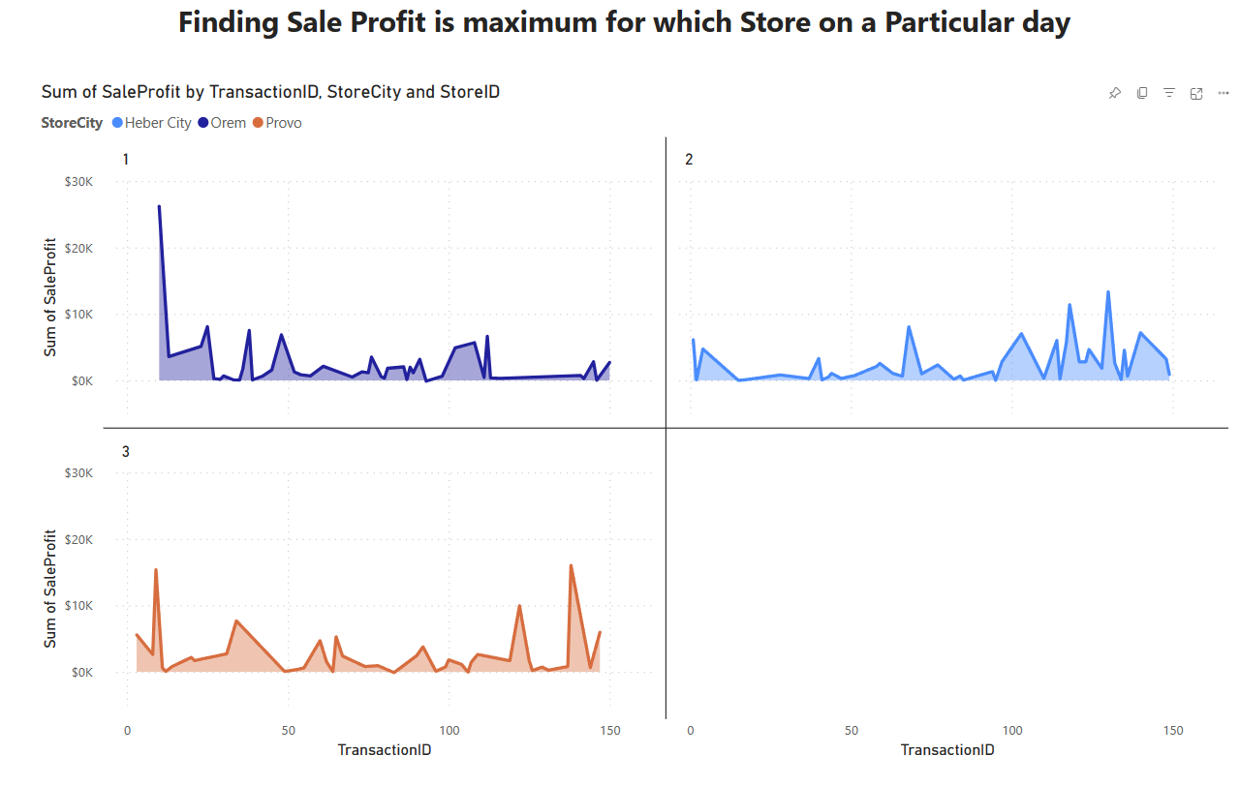

Link for these Visualizations:

Link to find all these visualizations: [Product vs Sale - Power BI](https://app.powerbi.com/groups/me/reports/ff2073ca-65a5-4f54-a34a-e9e2a329835a/ReportSection?experience=power-bi)

Python to create separate csv

*#splitting the Employee Address which contain Employee Address and their city seprated by a comma(,)*

df[['EmpAddress','EmpCity']]**=**df['Employee Address']**.**str**.**split(',',expand**=True**)

used this code to separate Address

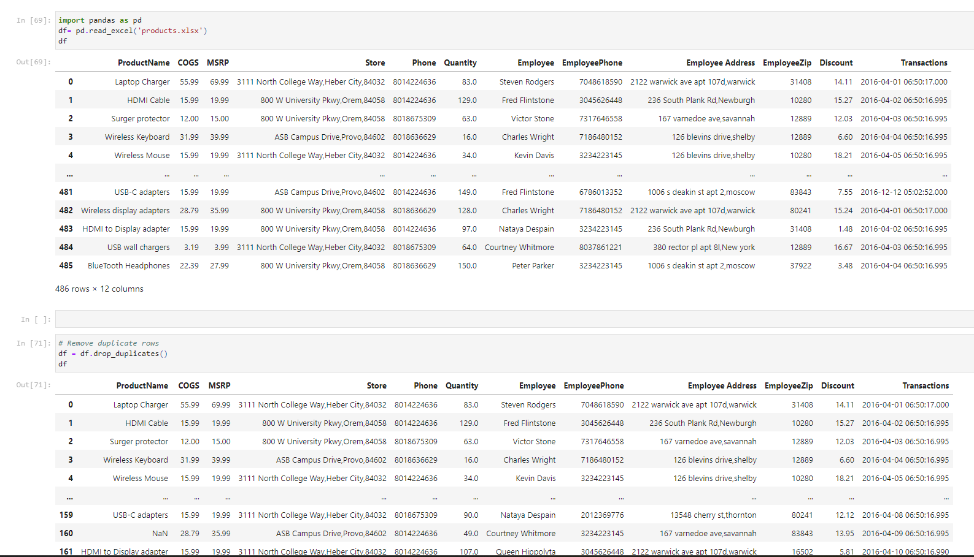

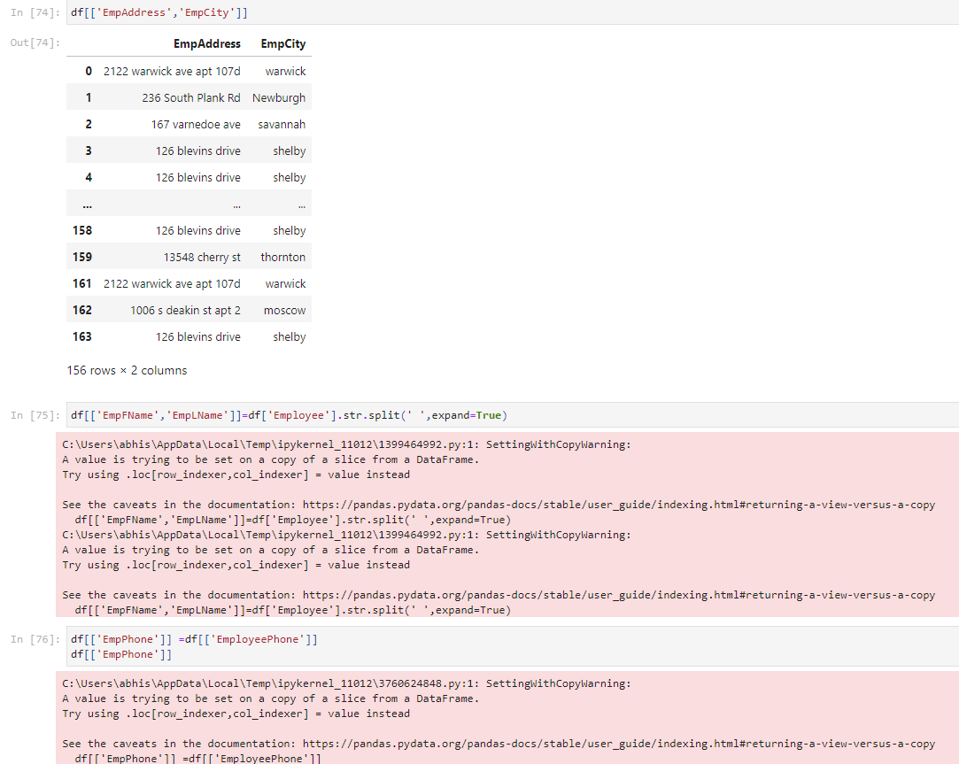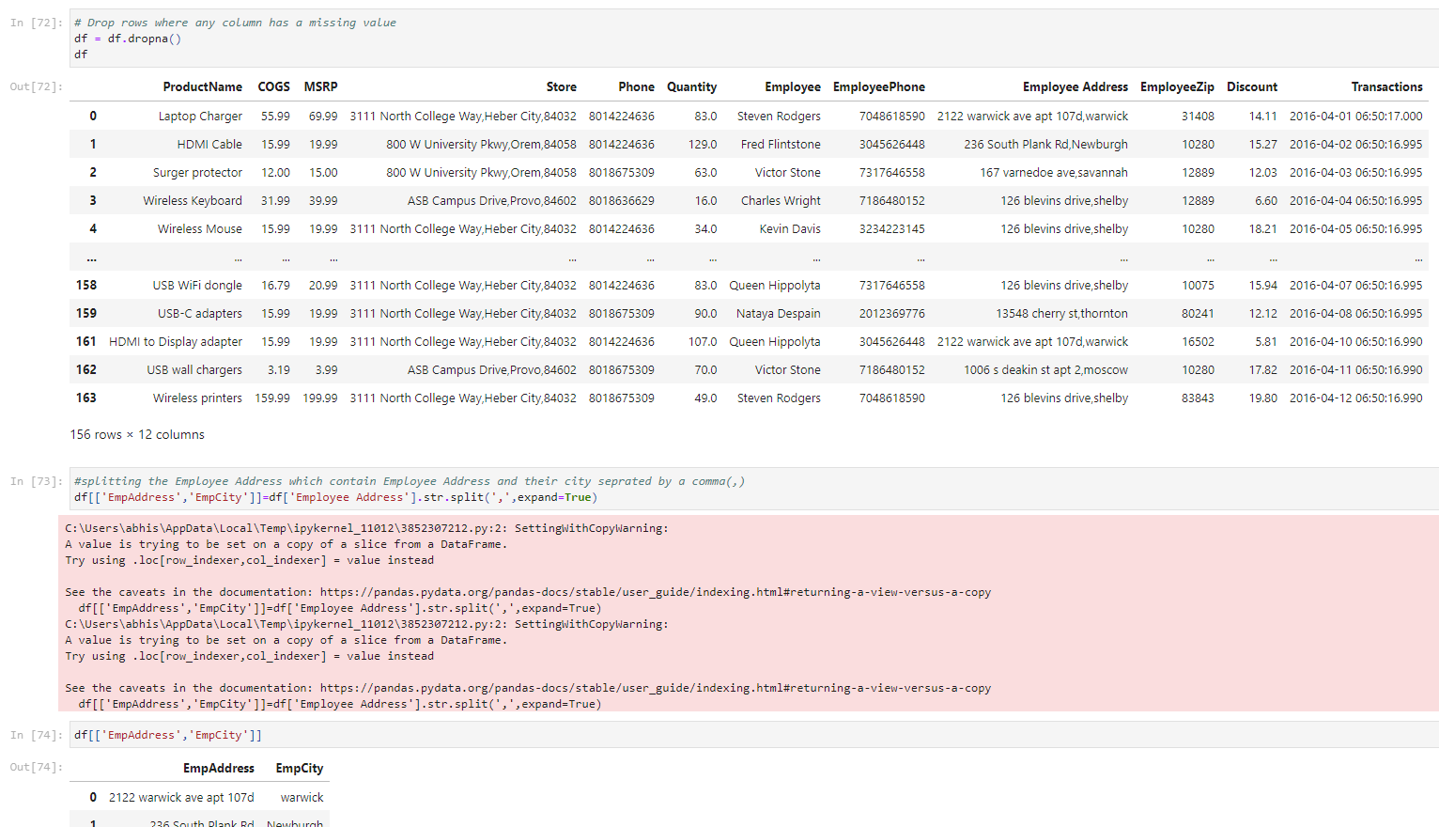

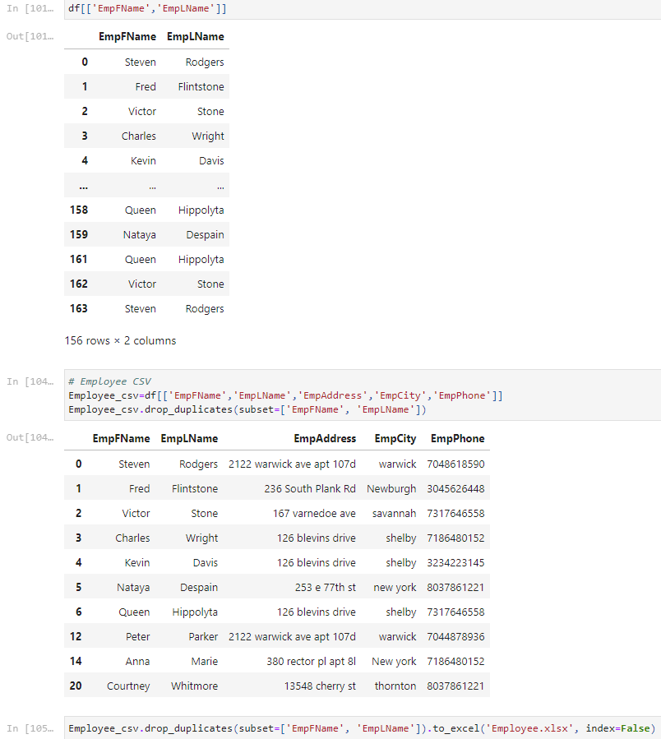

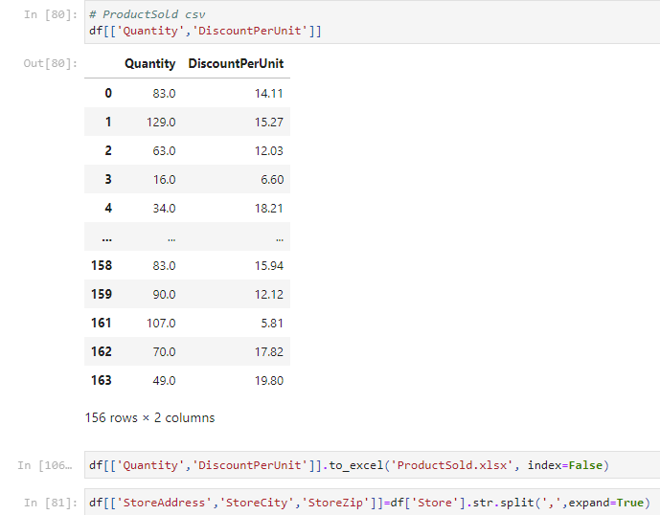

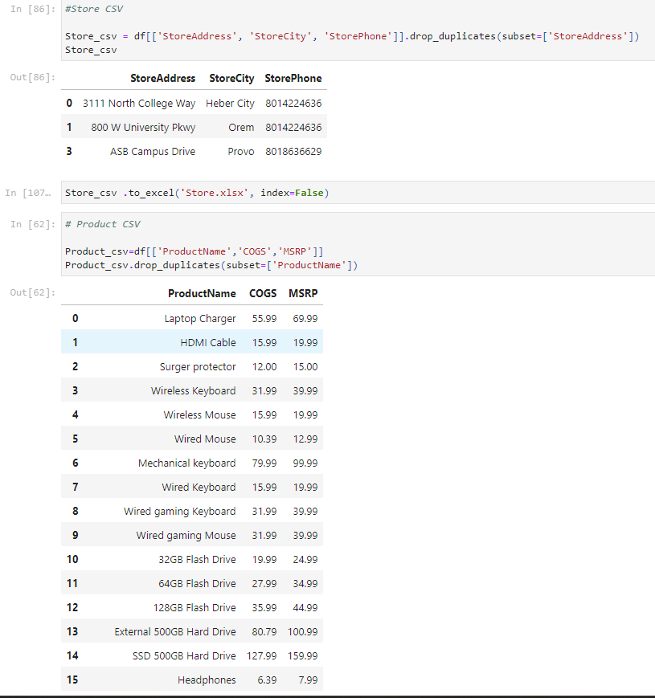

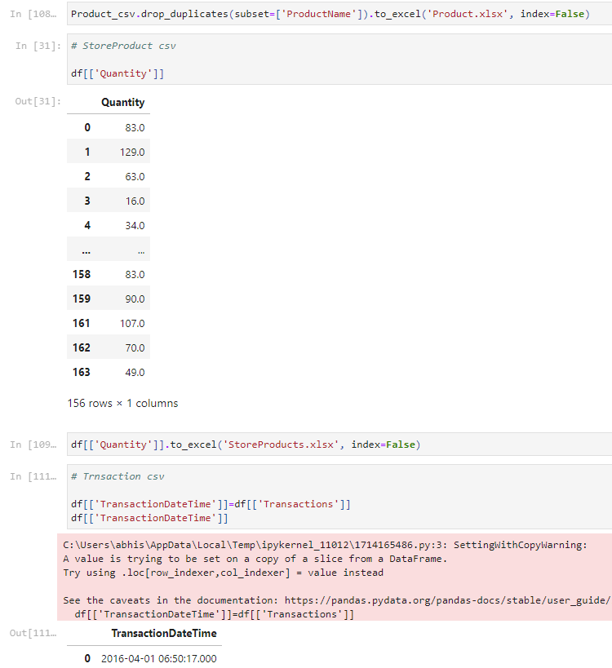

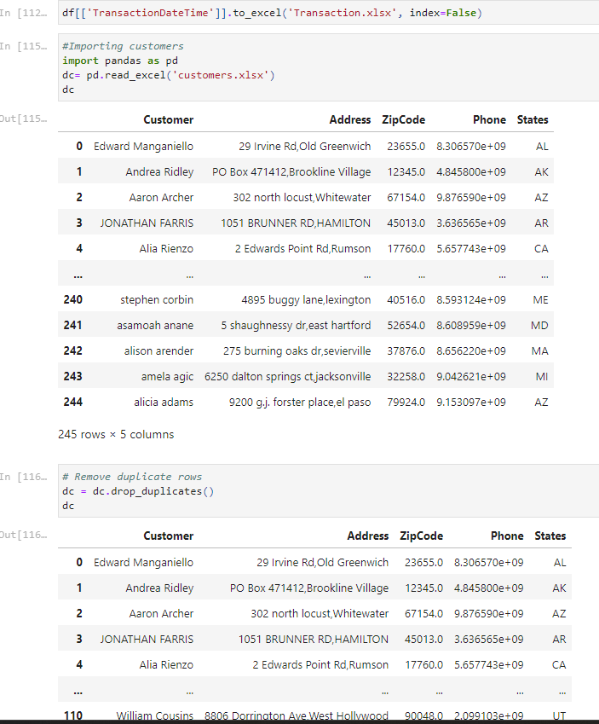

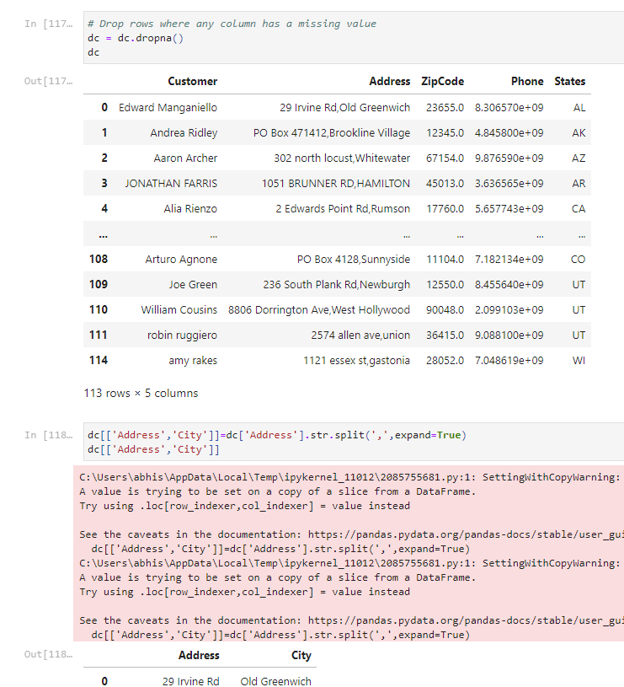

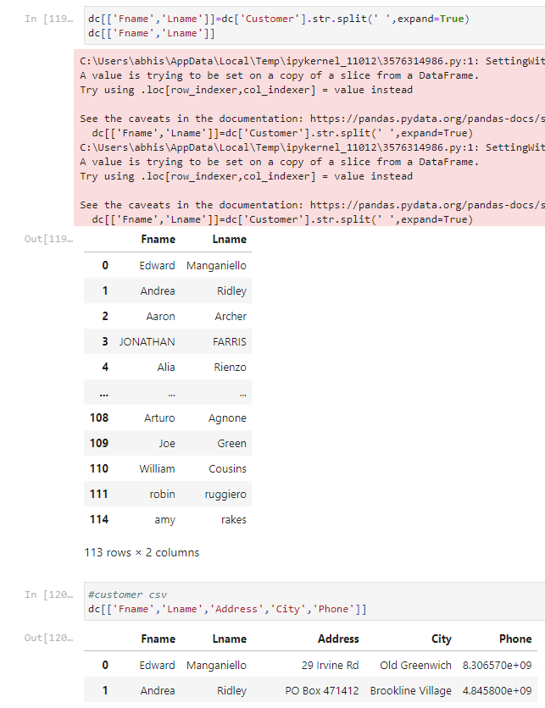

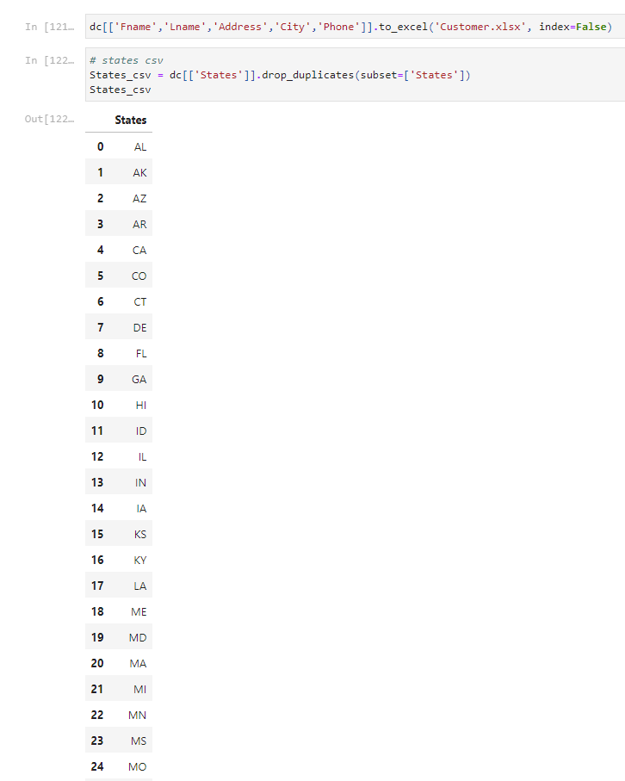

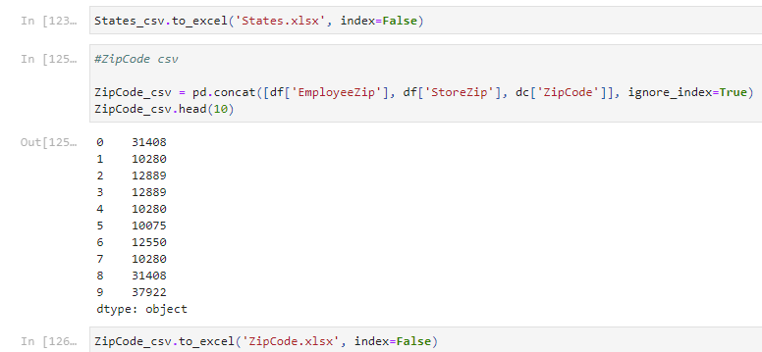

Importing to existing tables to SQL Server using Data Pump

**States**

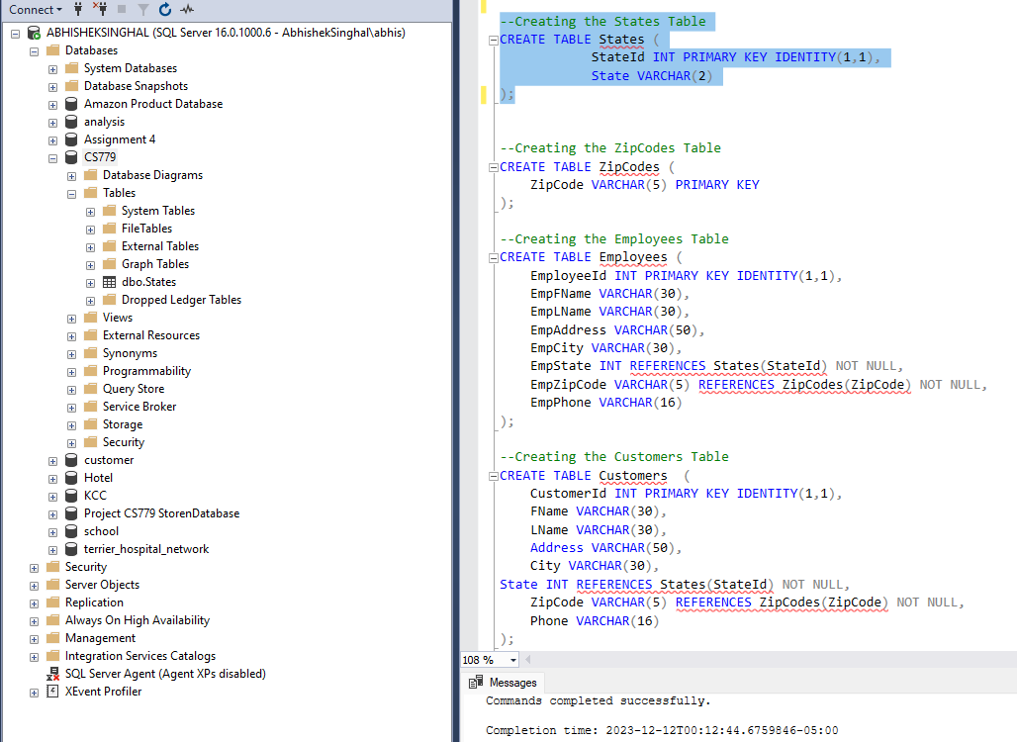

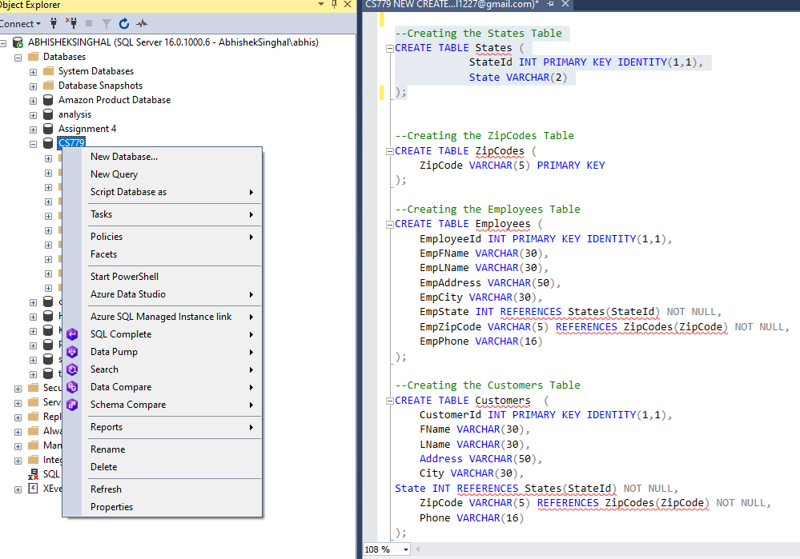

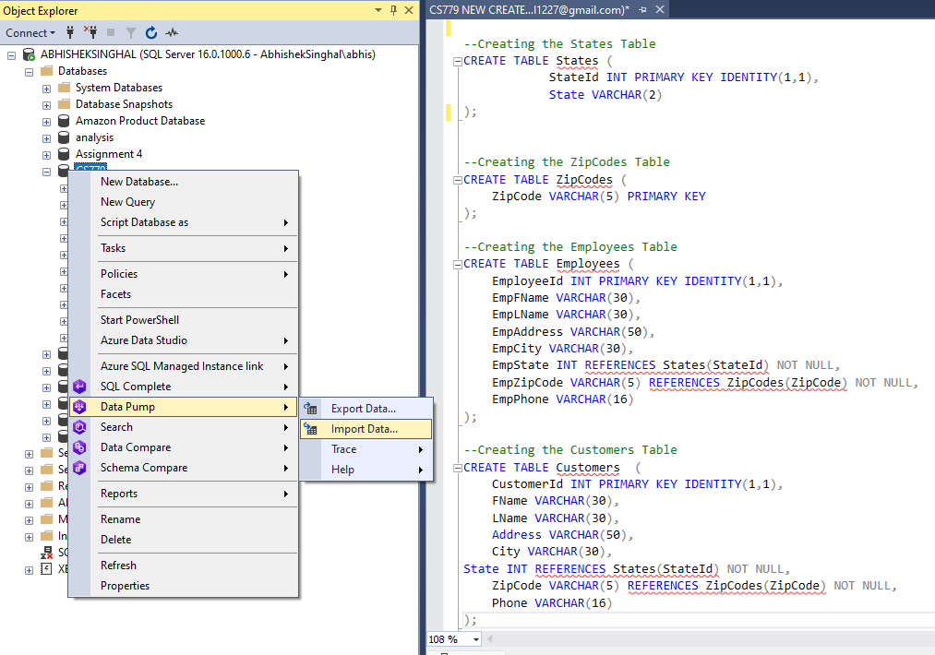

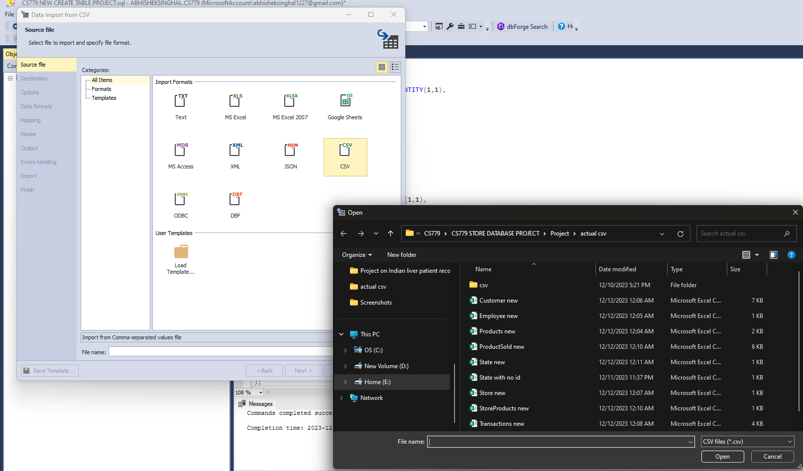

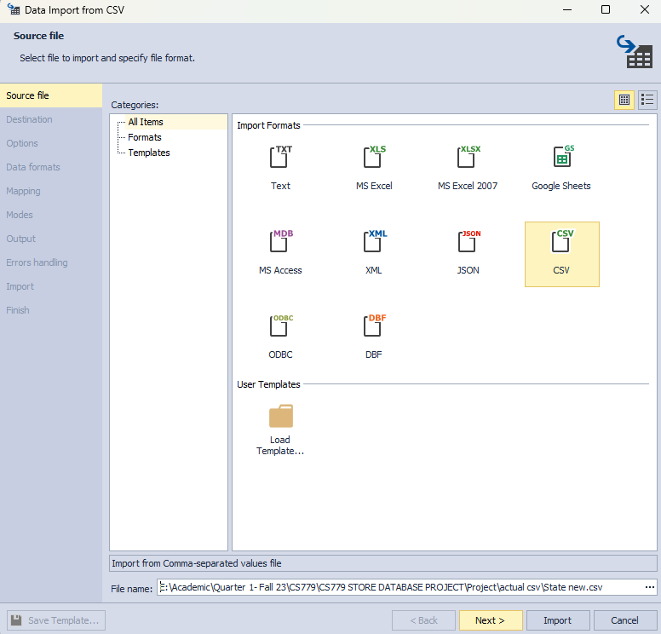

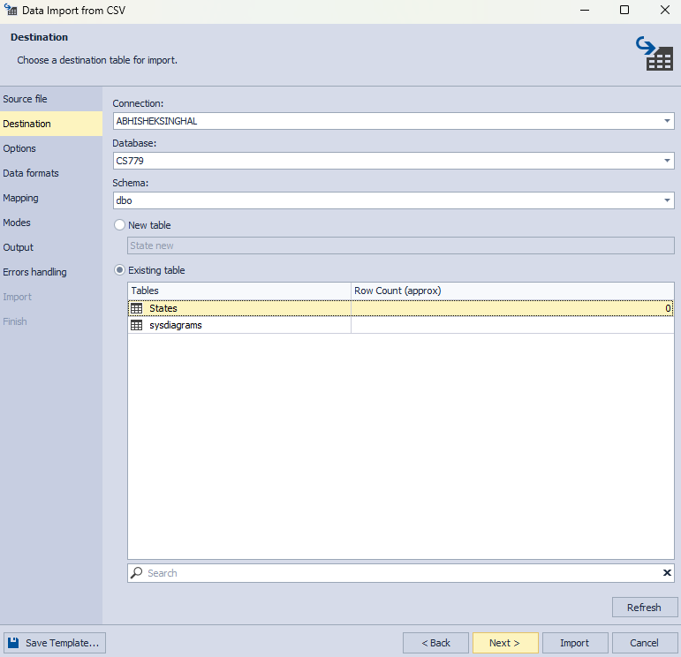

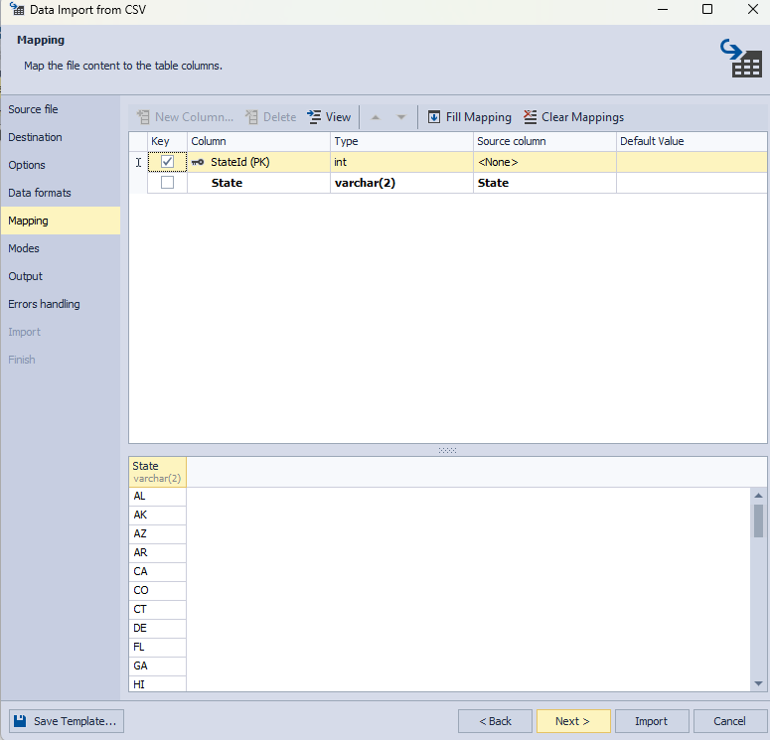

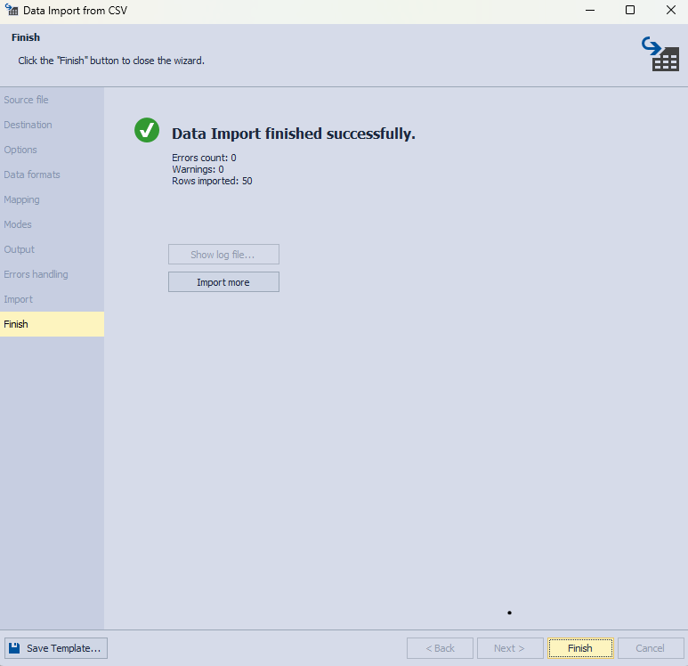

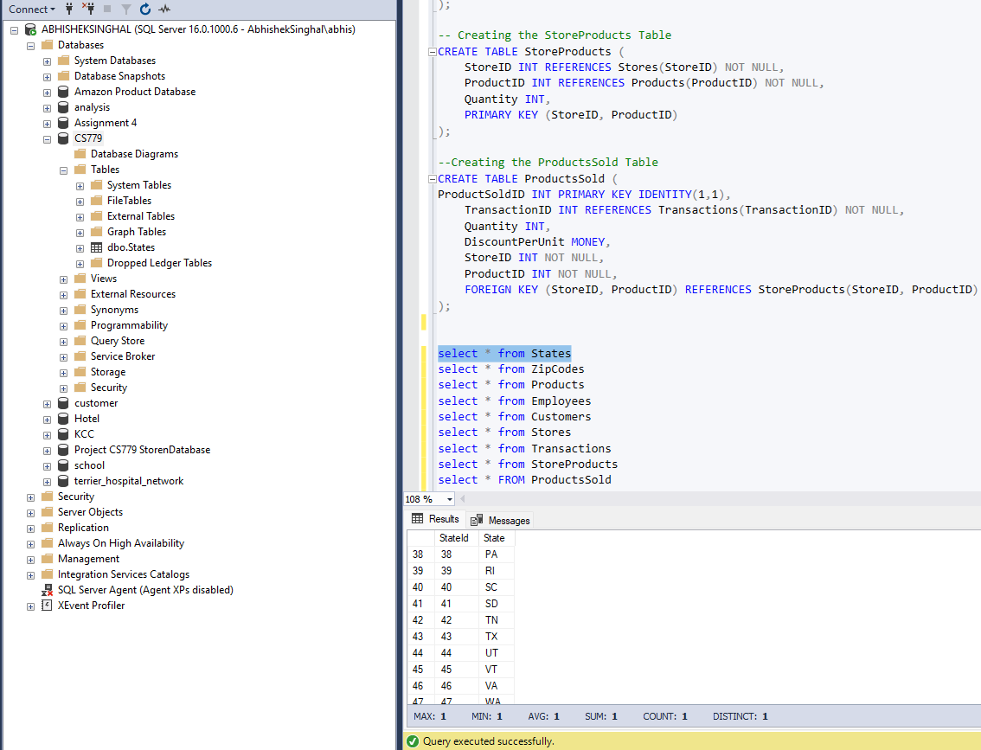

**ZipCodes**

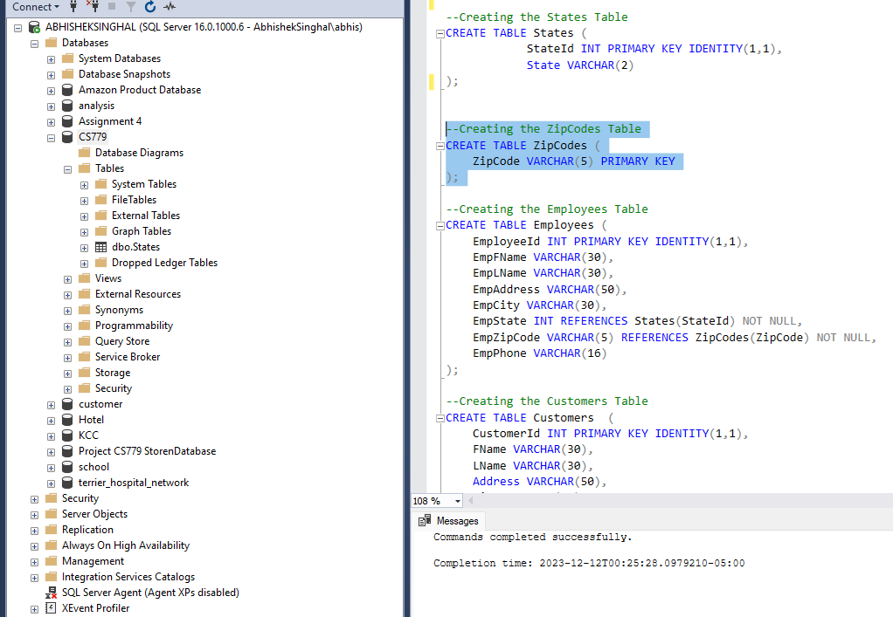

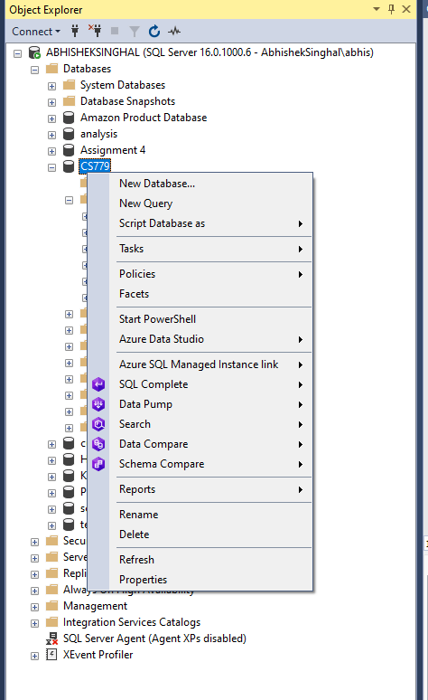





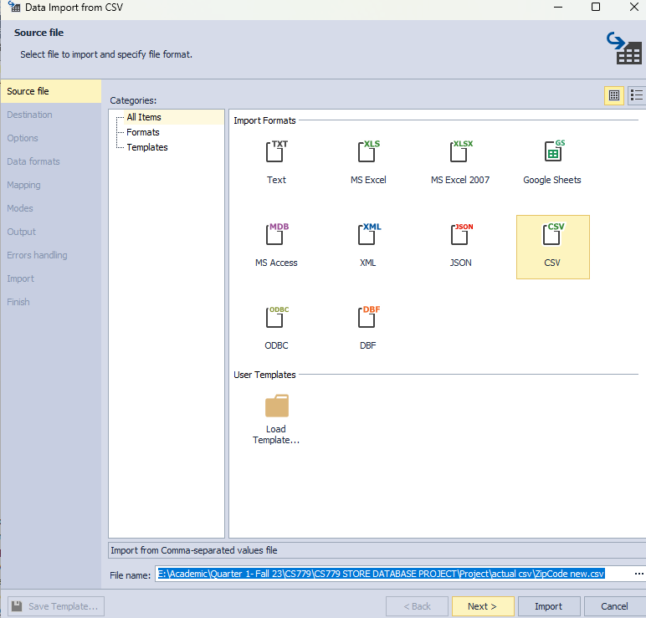

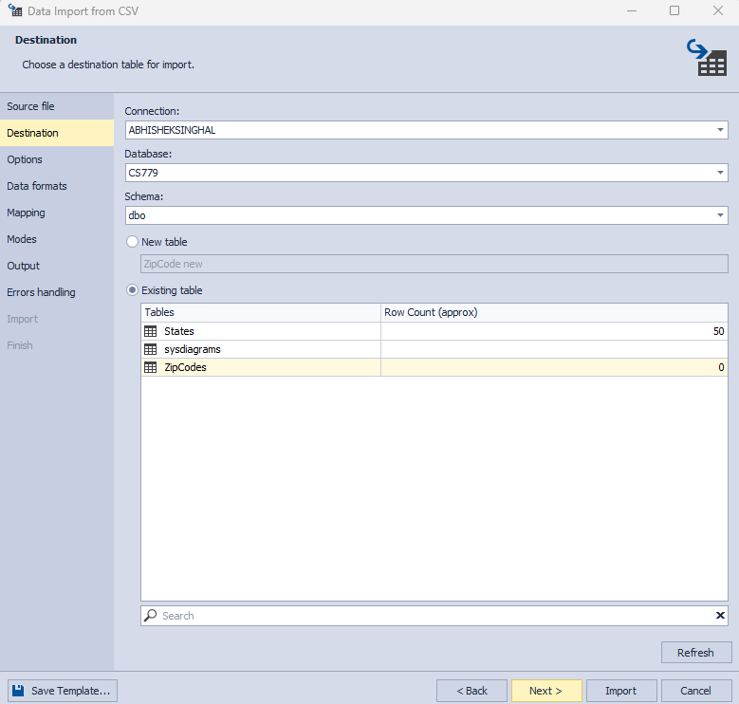

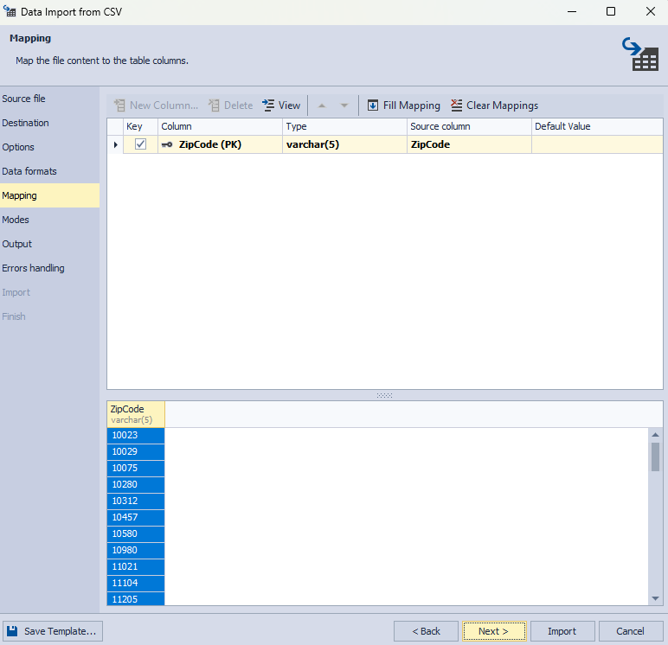

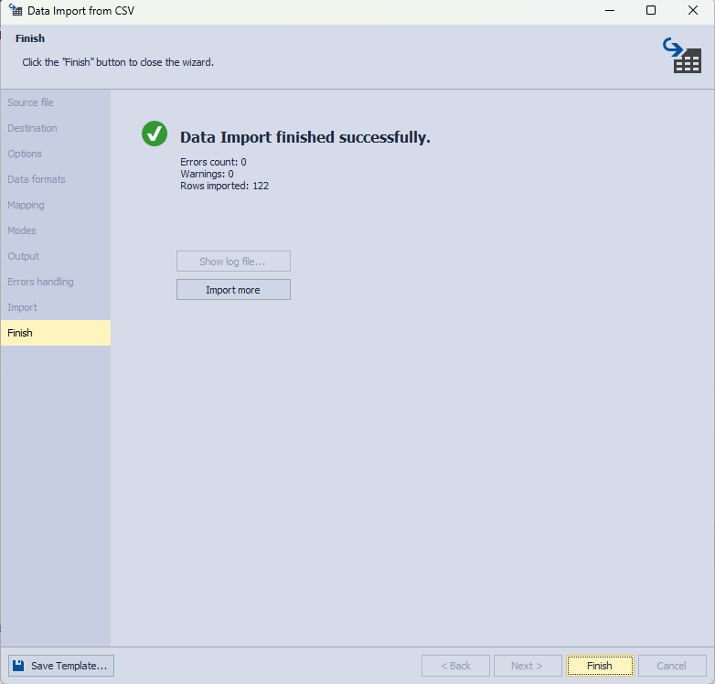

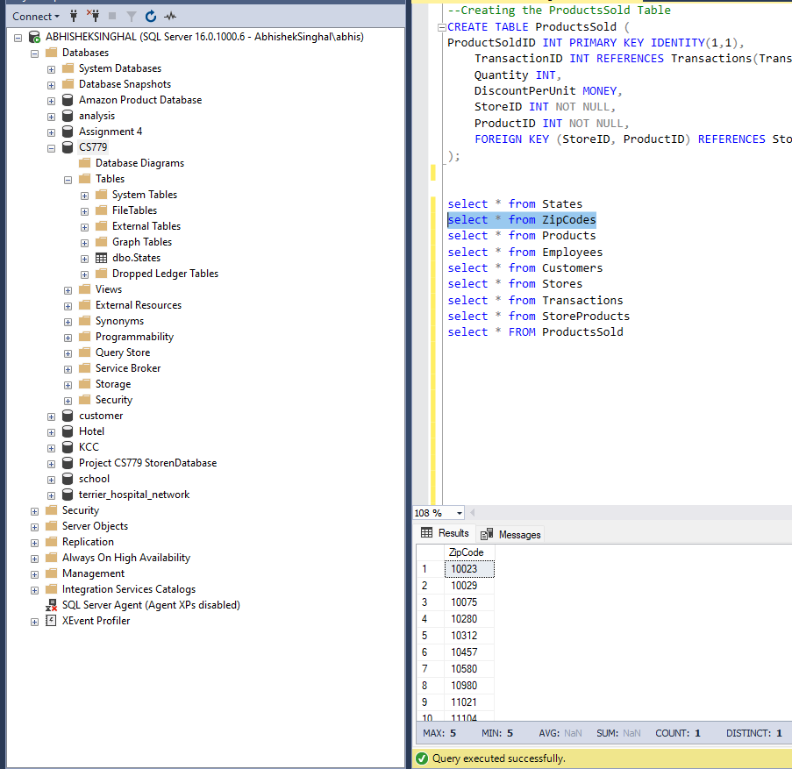

**Products**

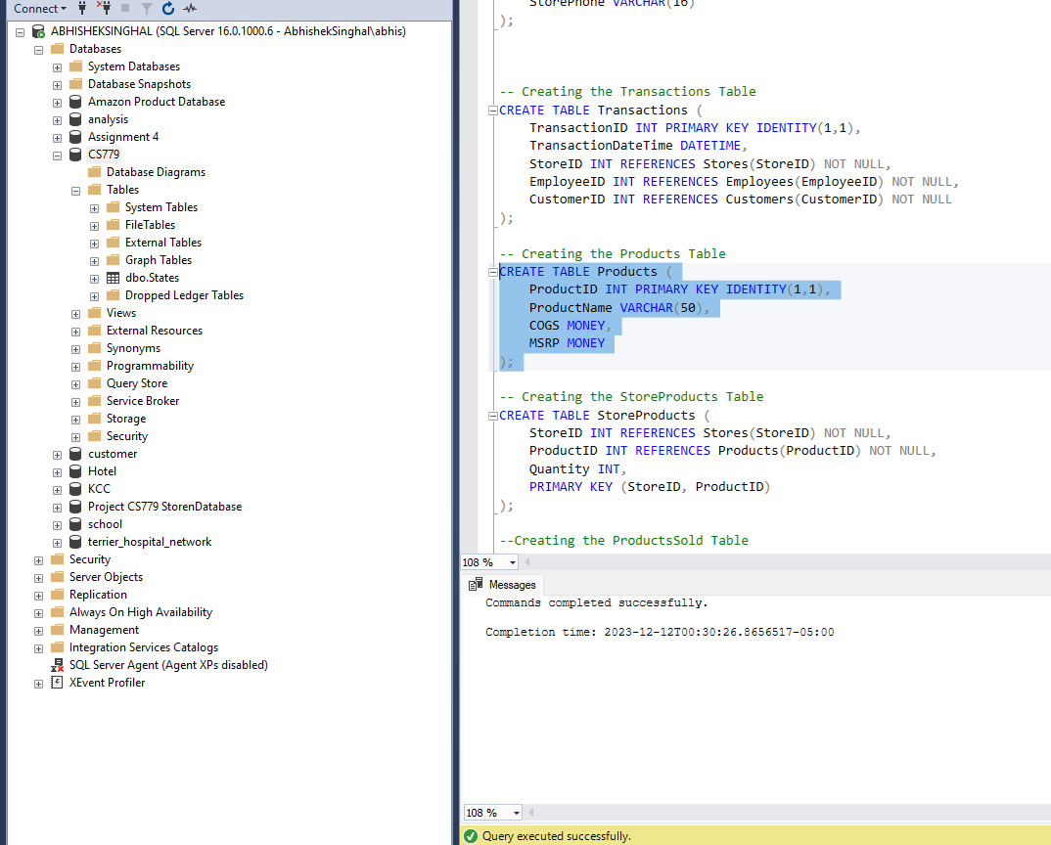







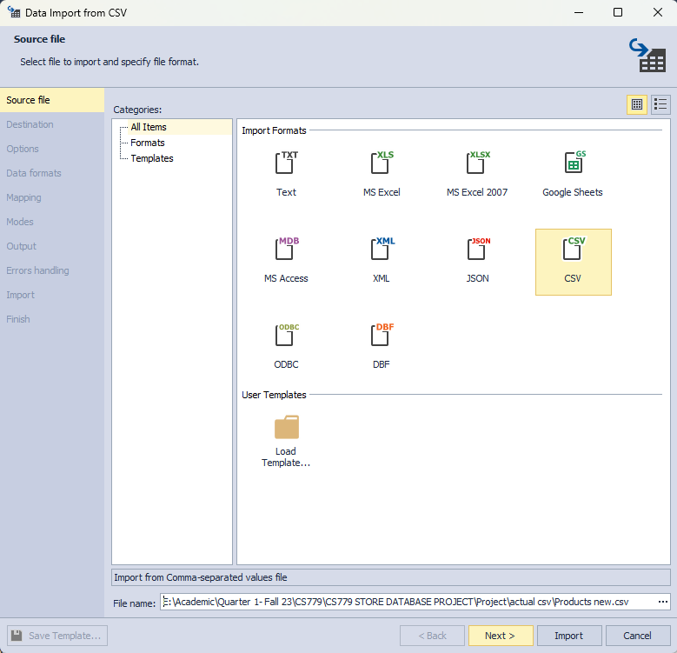

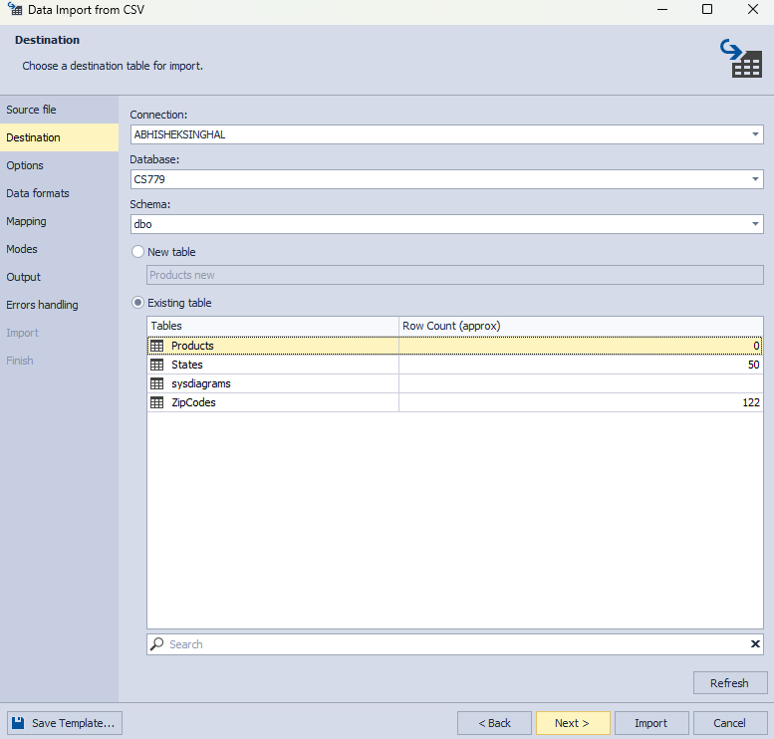

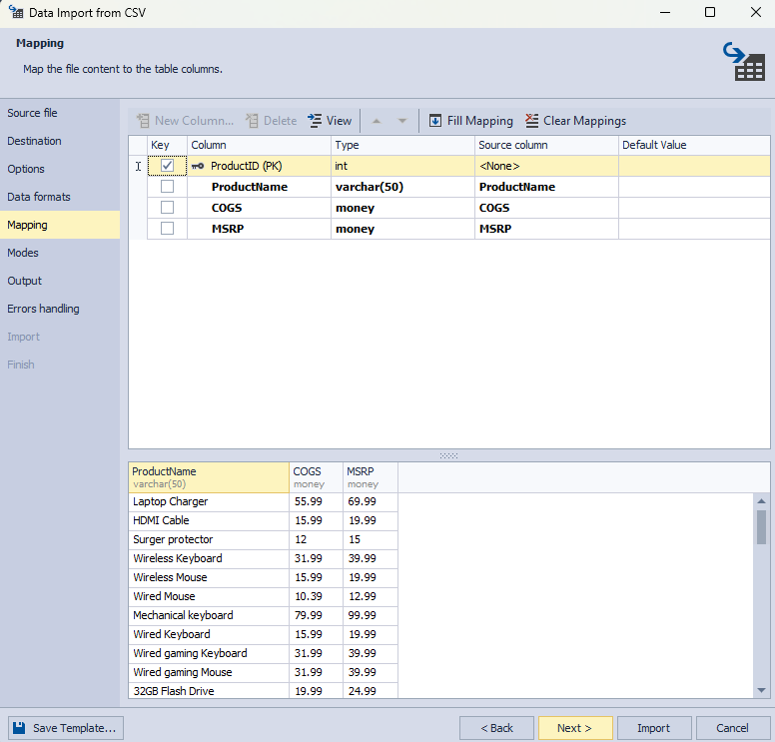

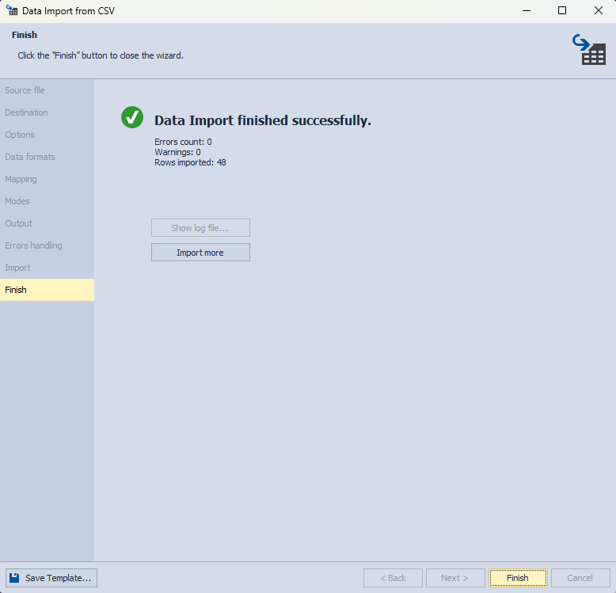

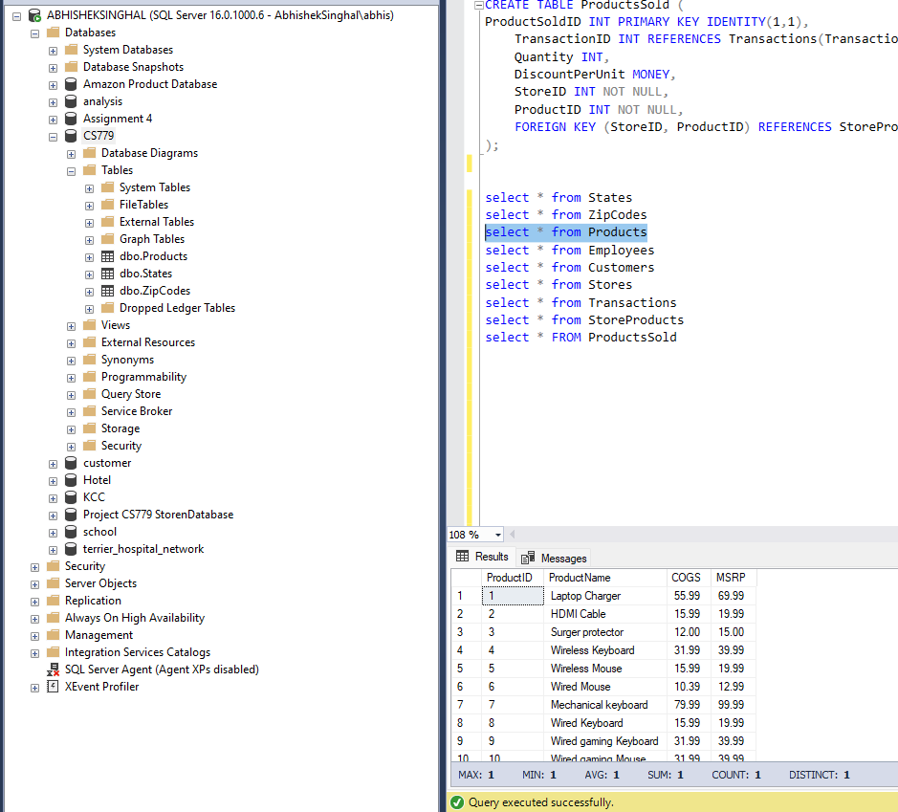

**Employees**

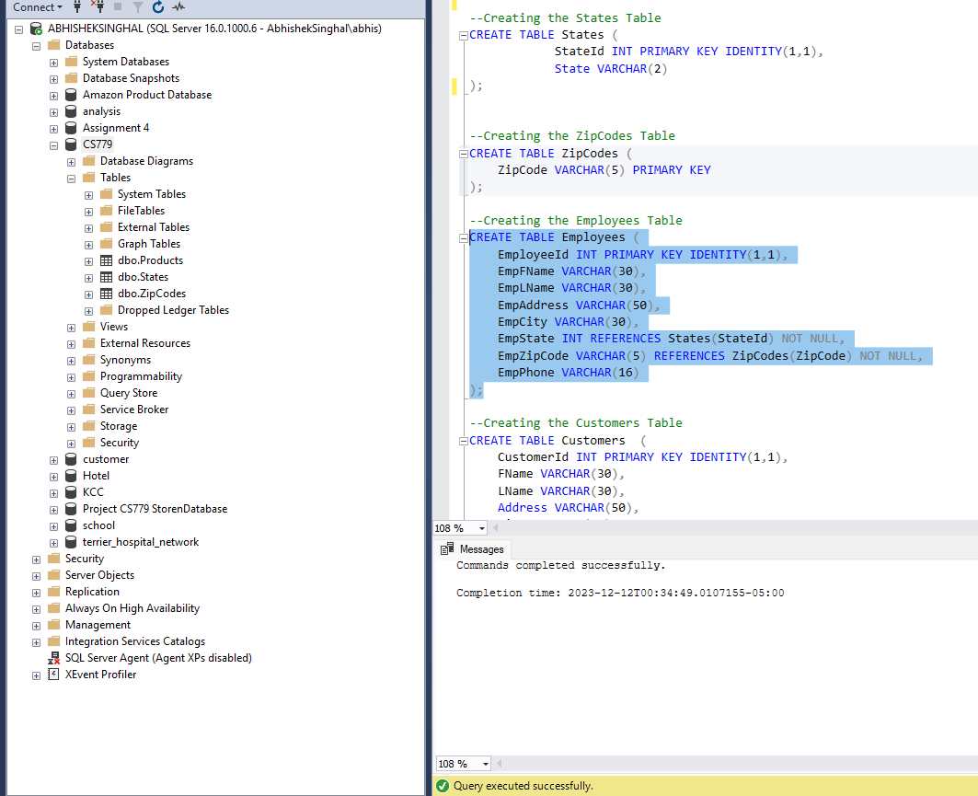

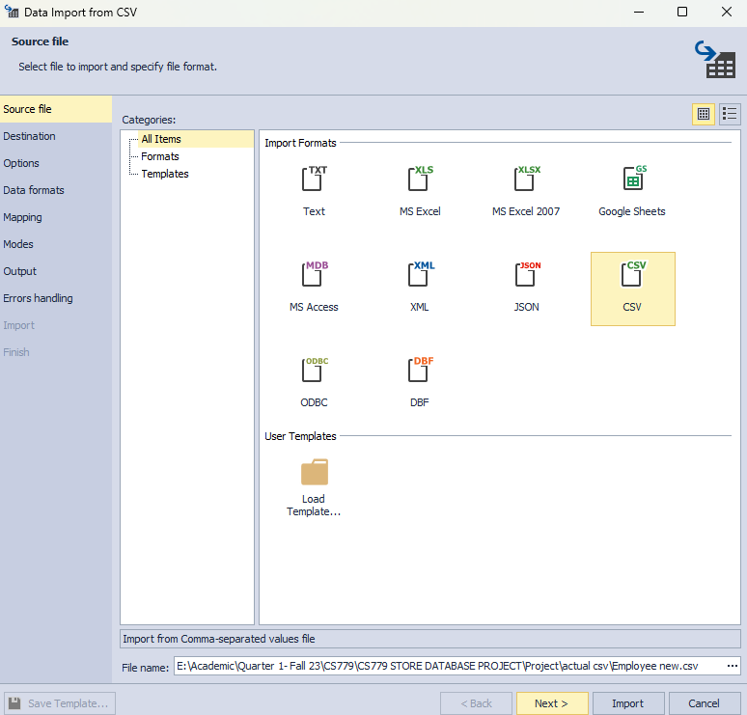

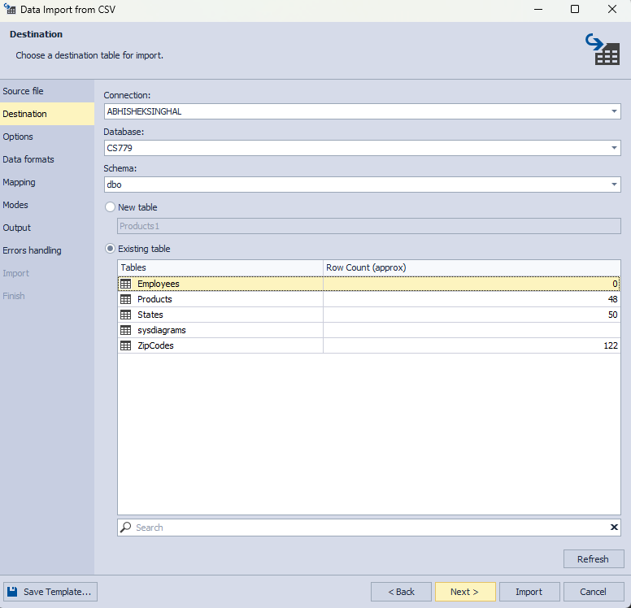

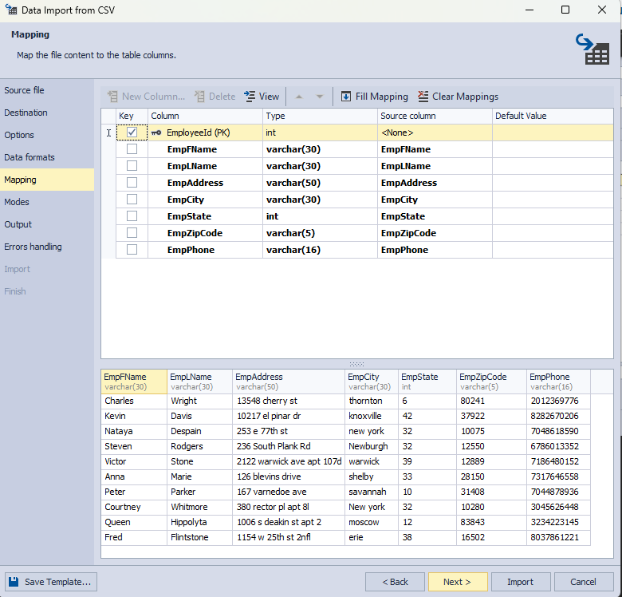

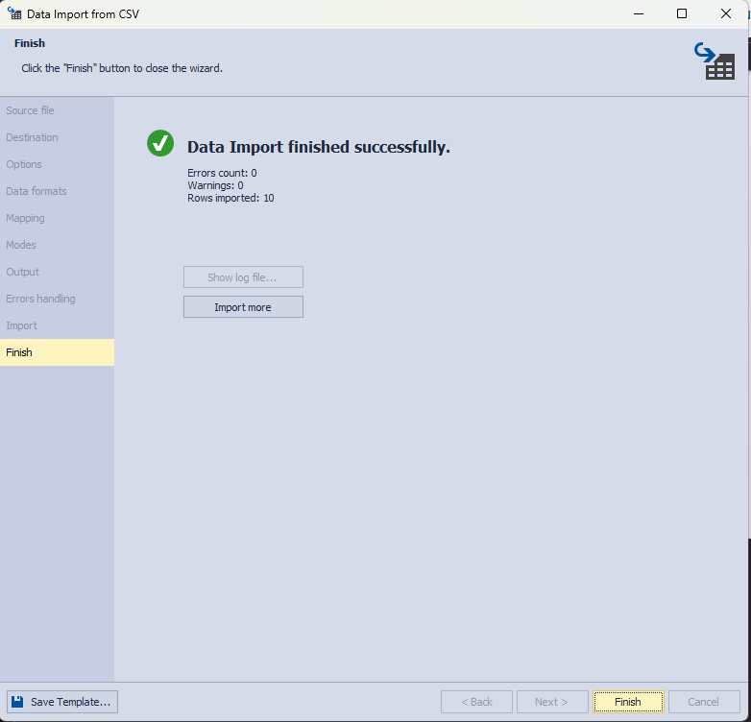

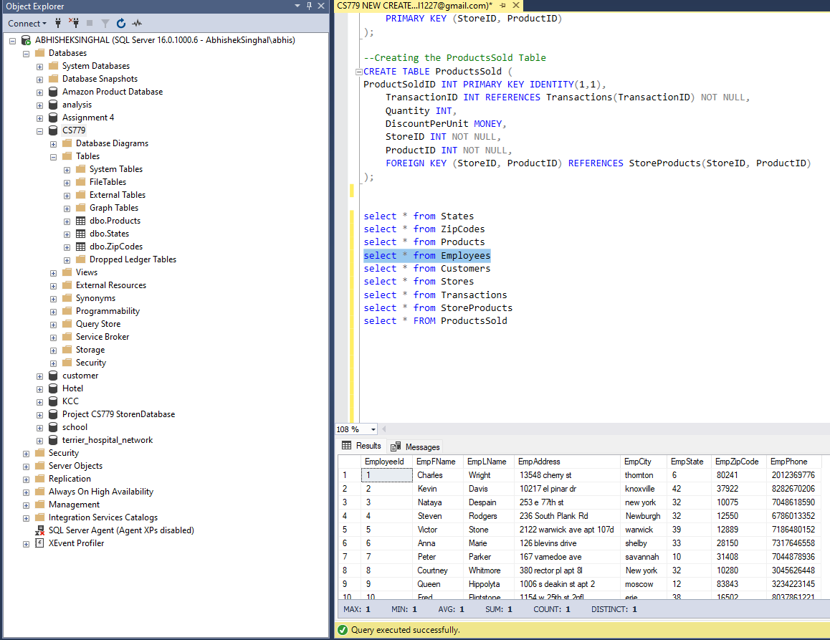

**Customers**

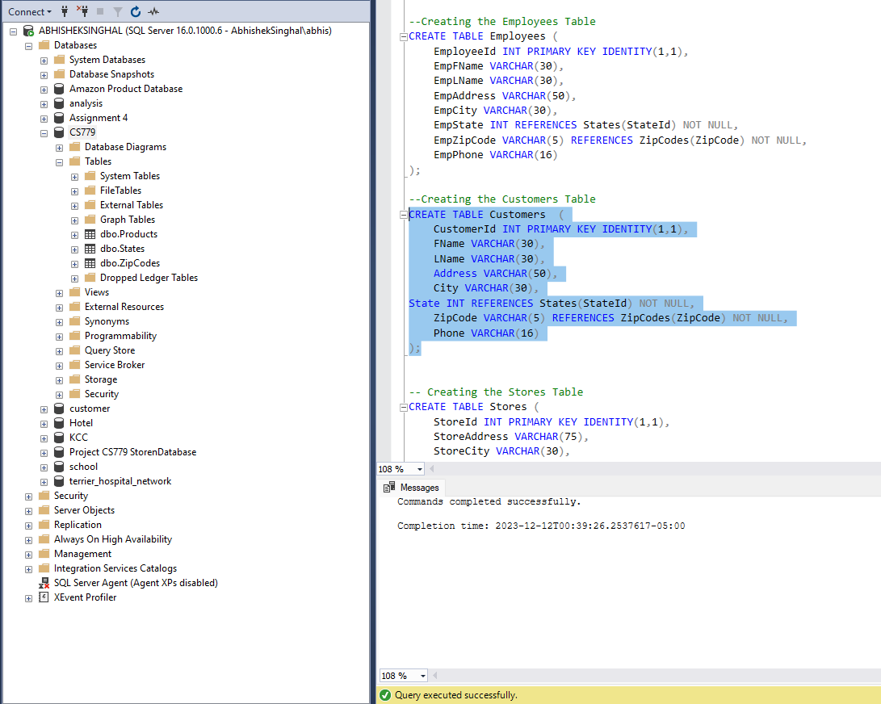







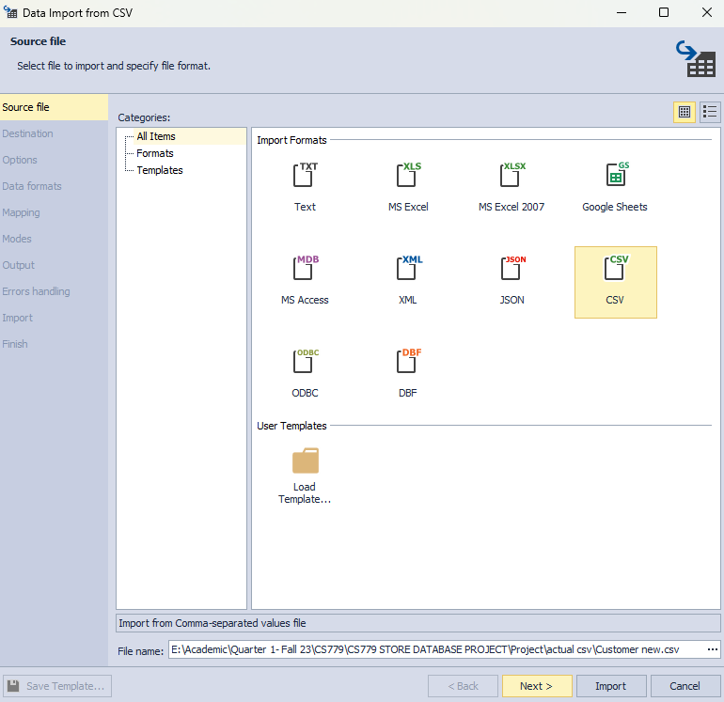

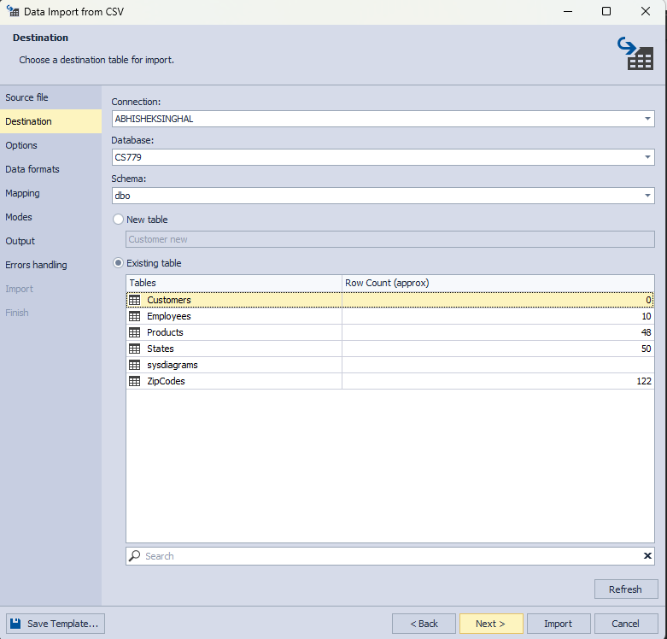

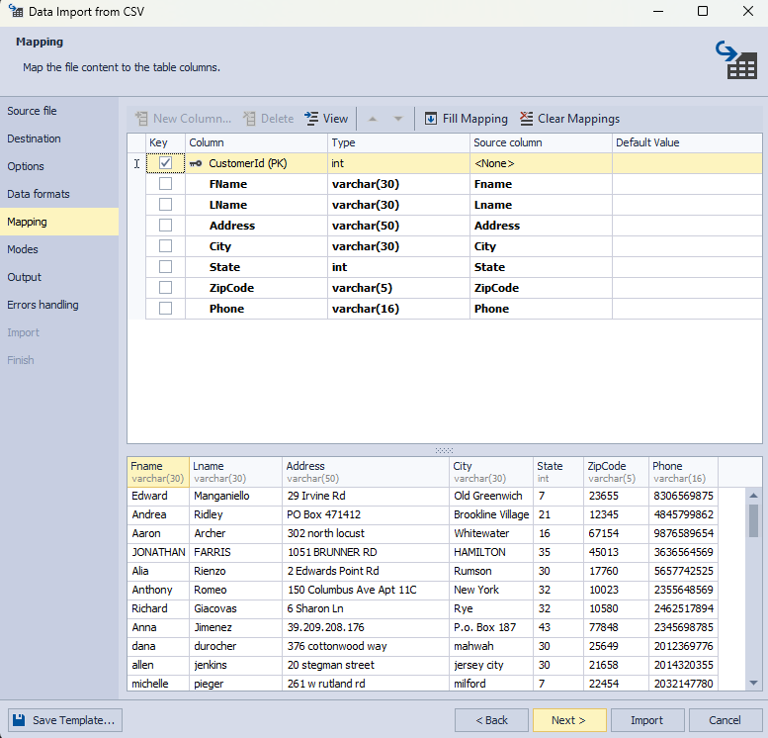

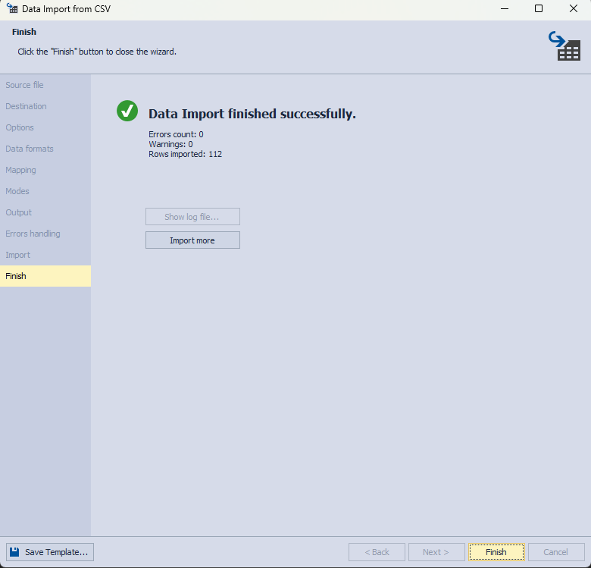

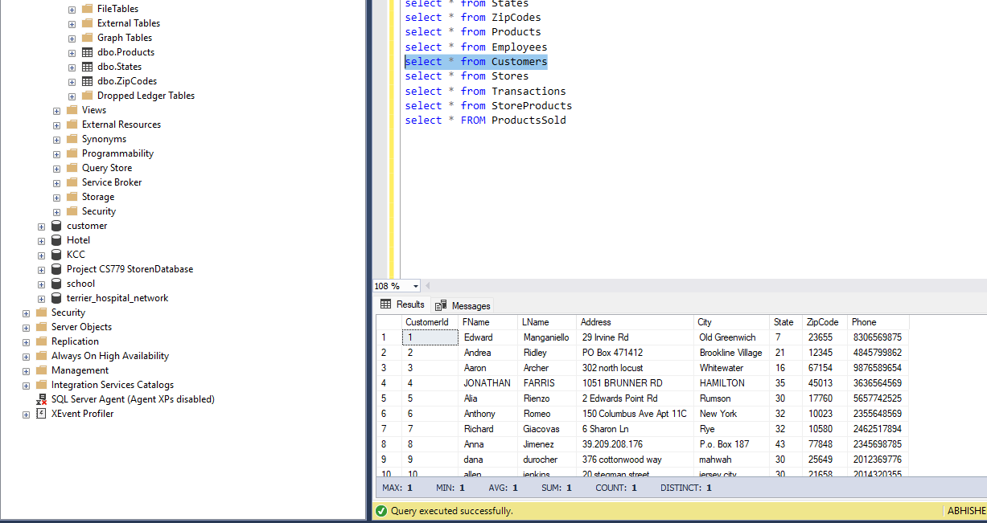

**Stores**

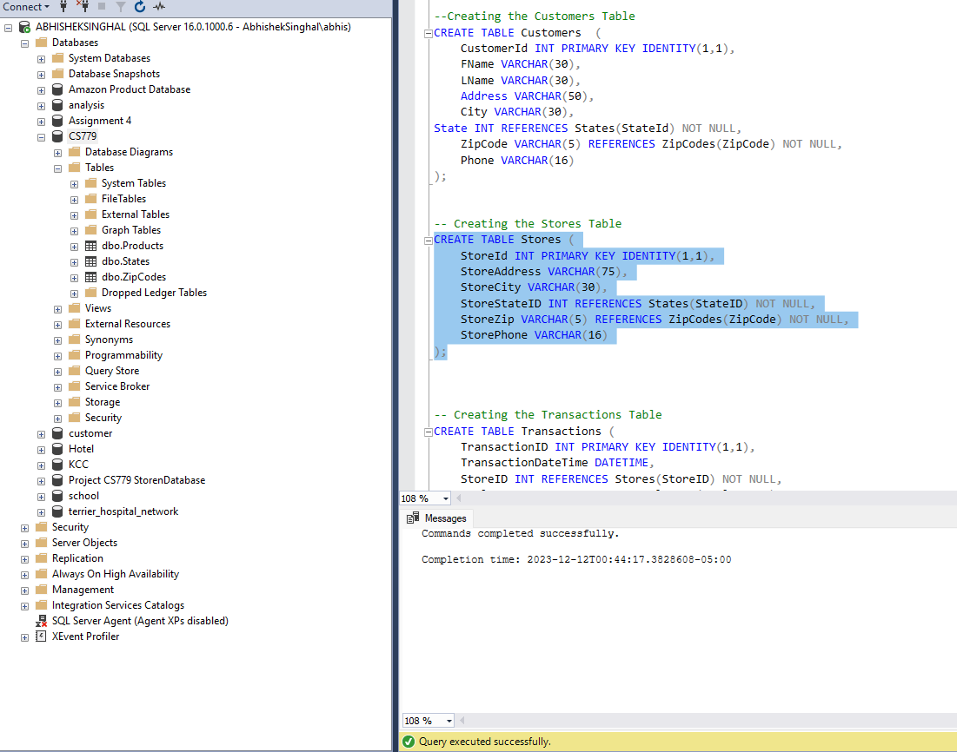







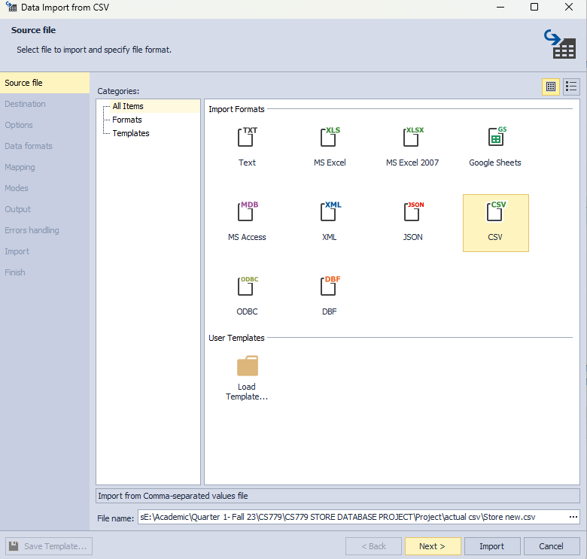

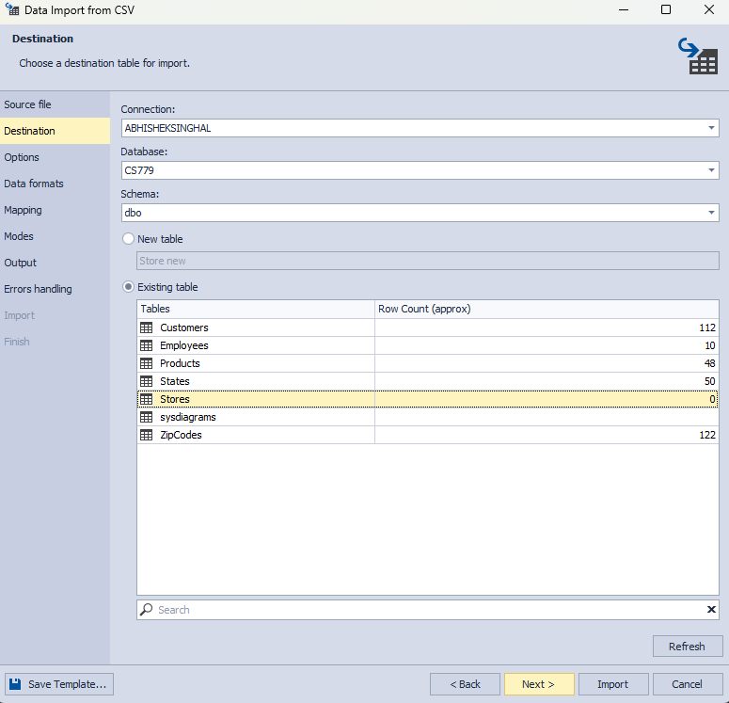

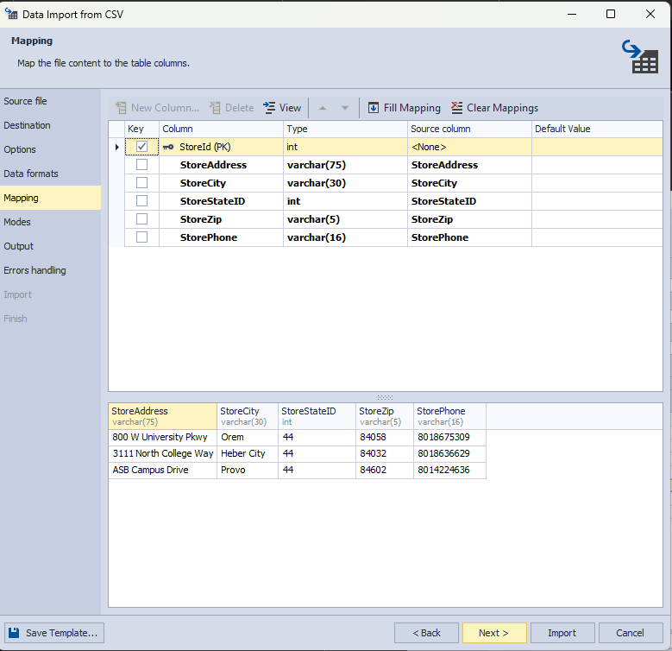

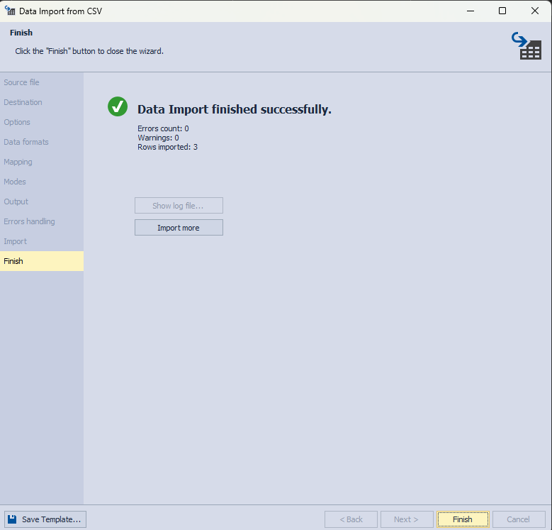

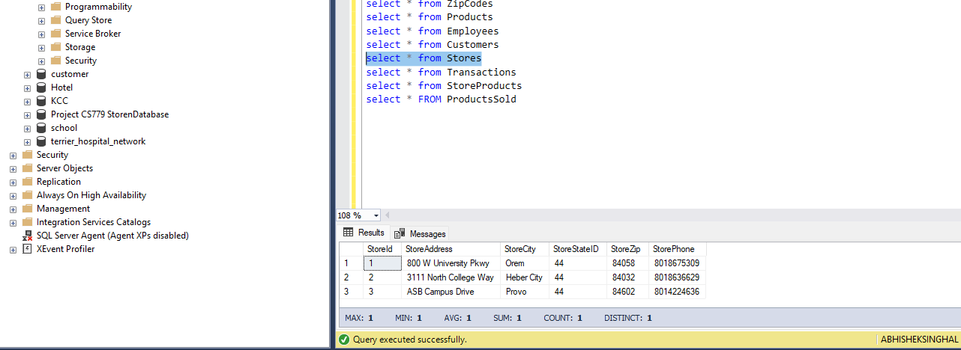

**Transactions**

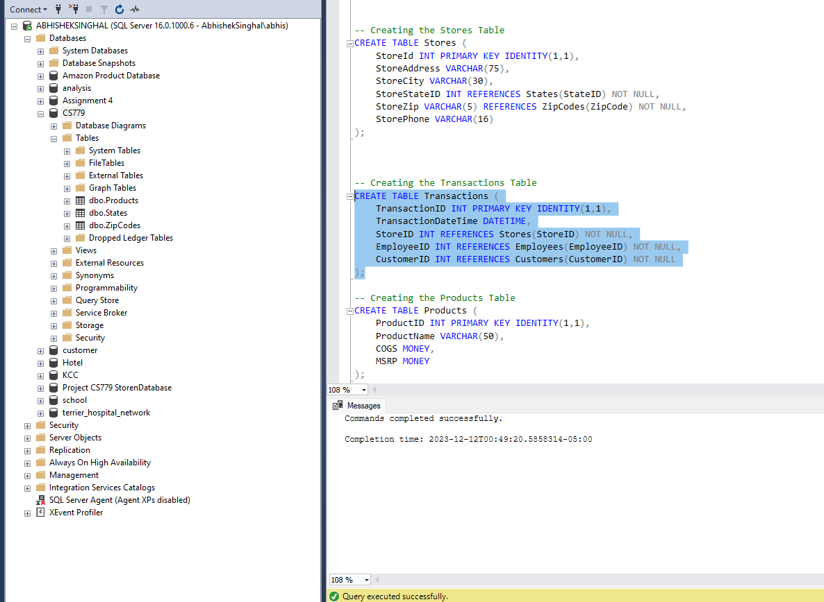







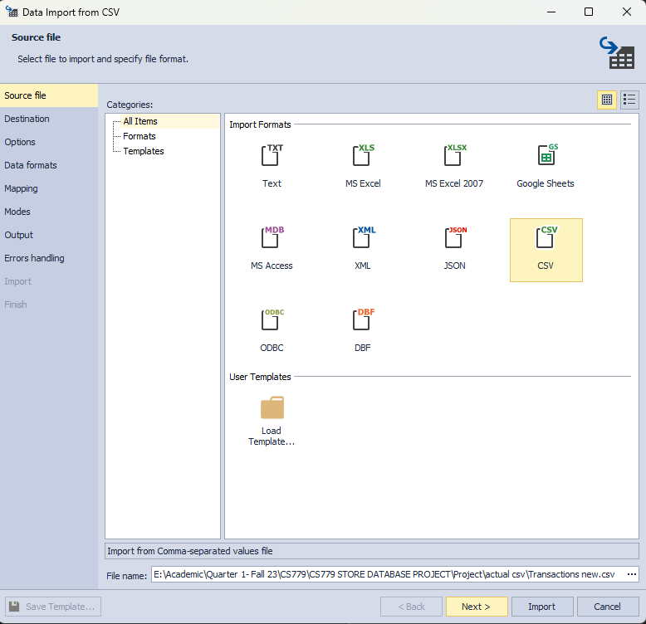

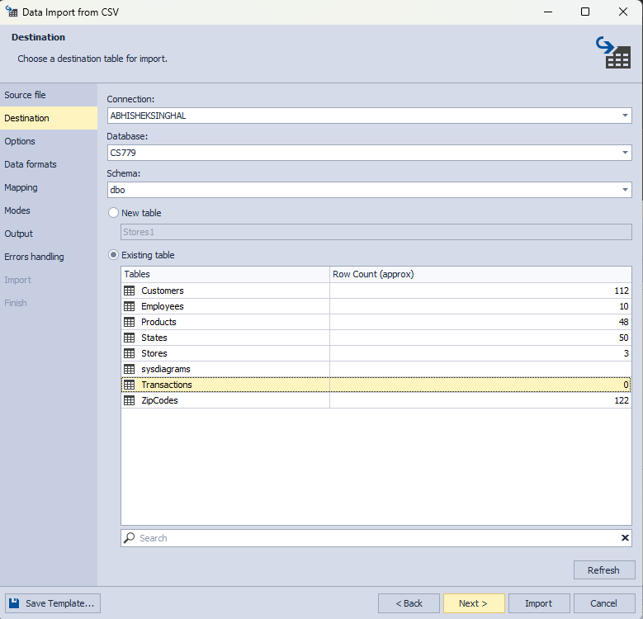

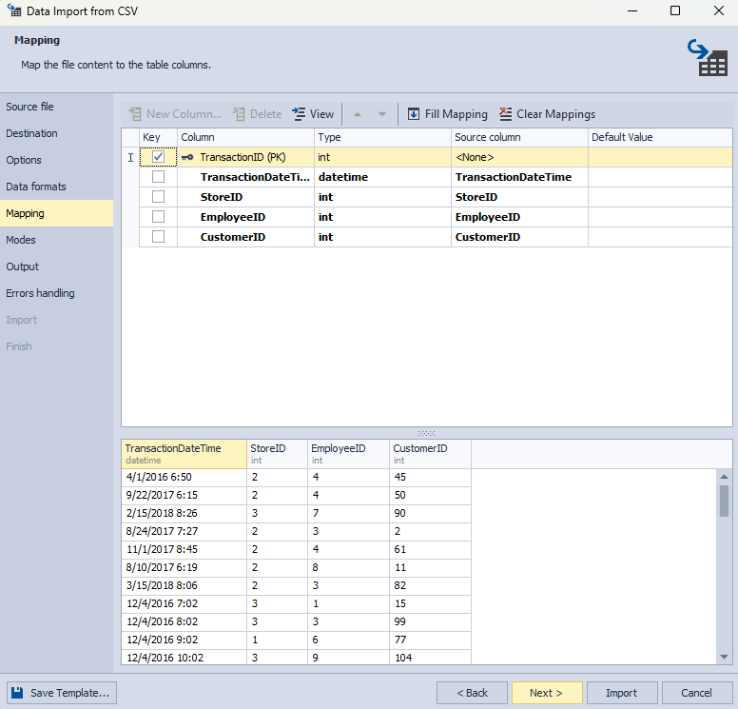

v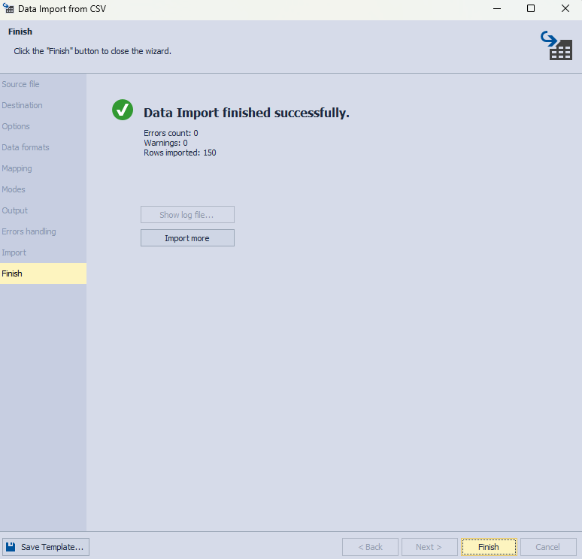

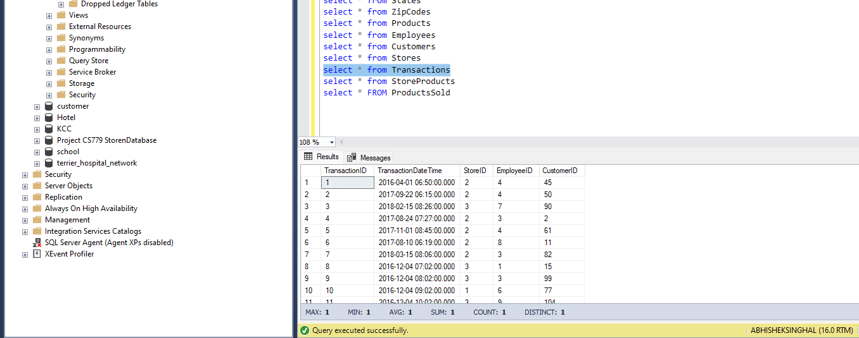

**StoreProducts**

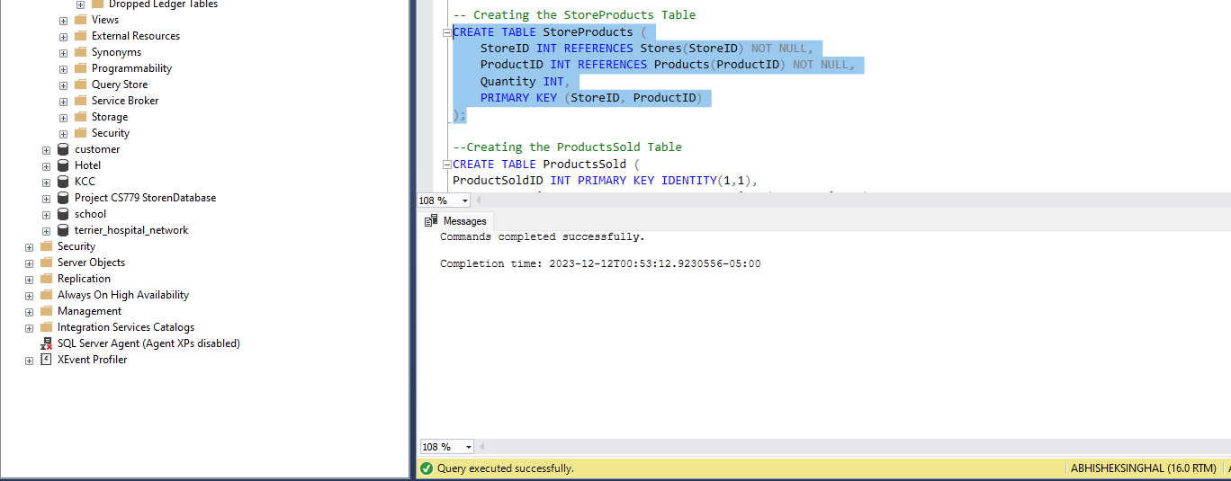







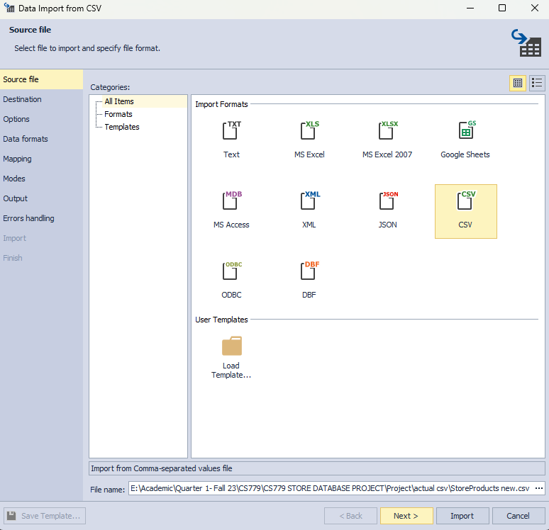

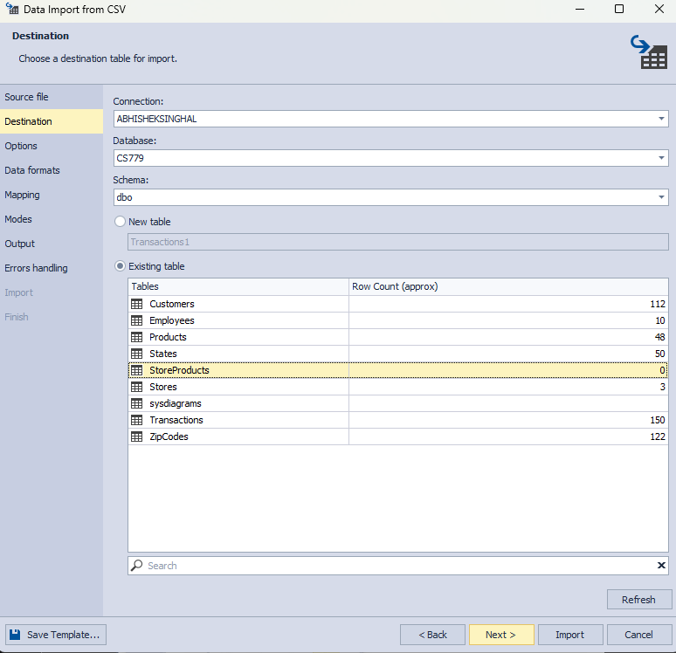

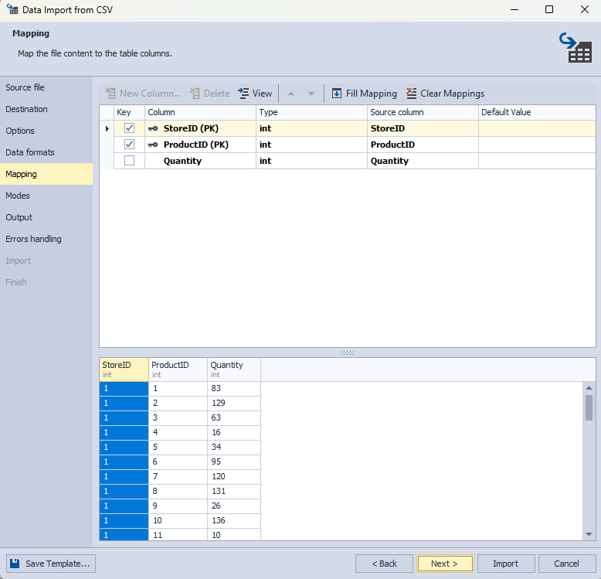

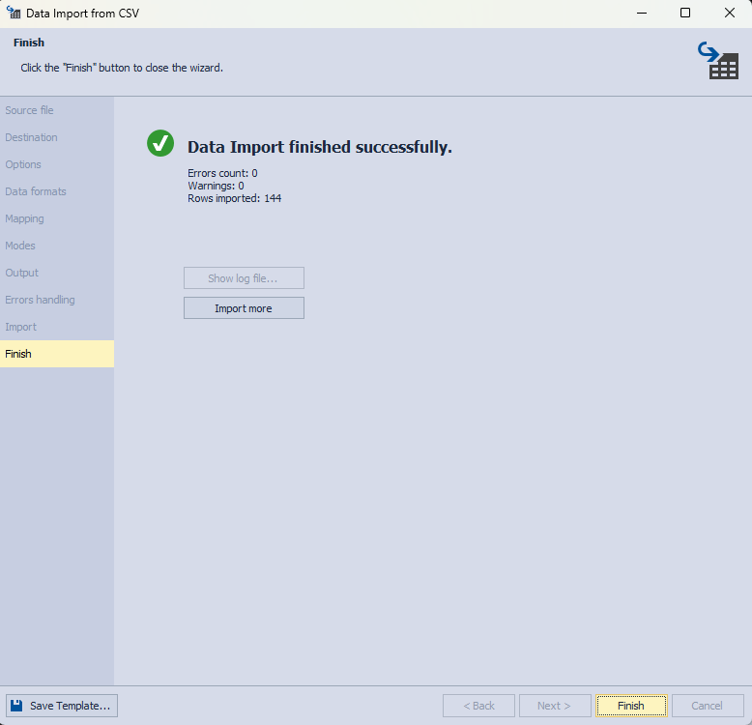

v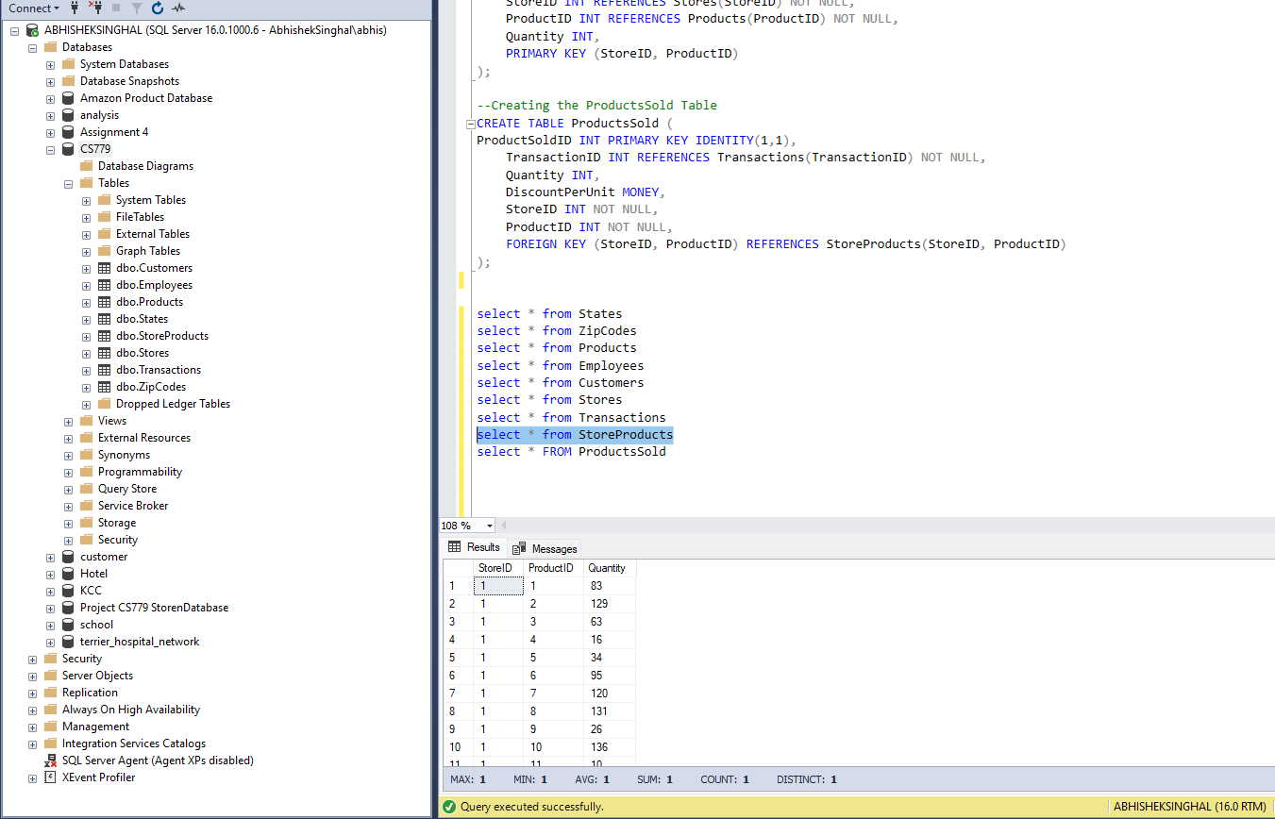

**ProductsSold**

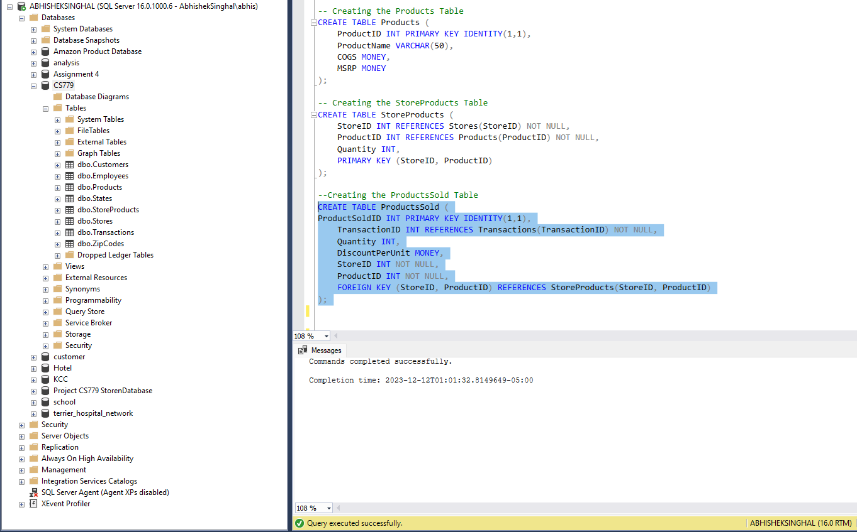







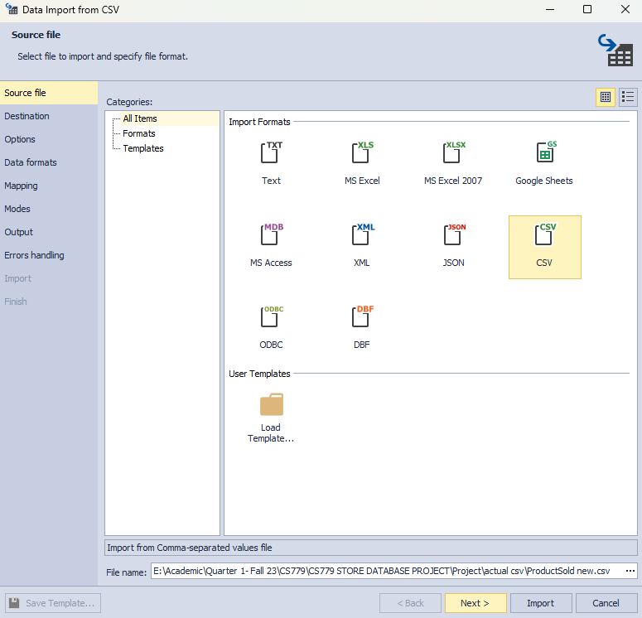

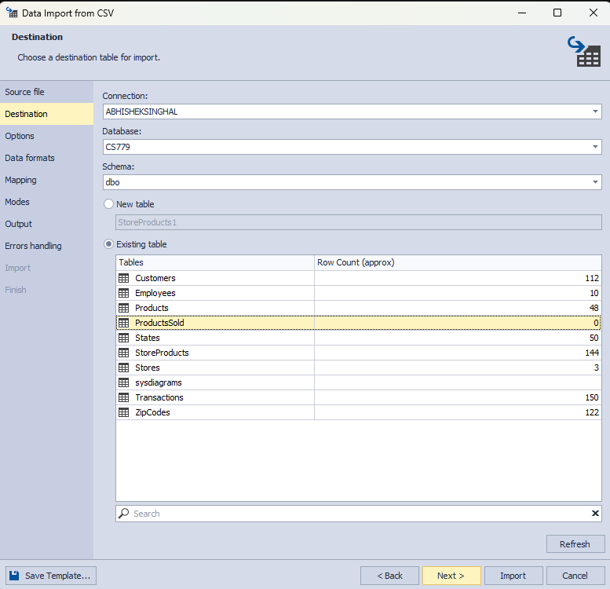

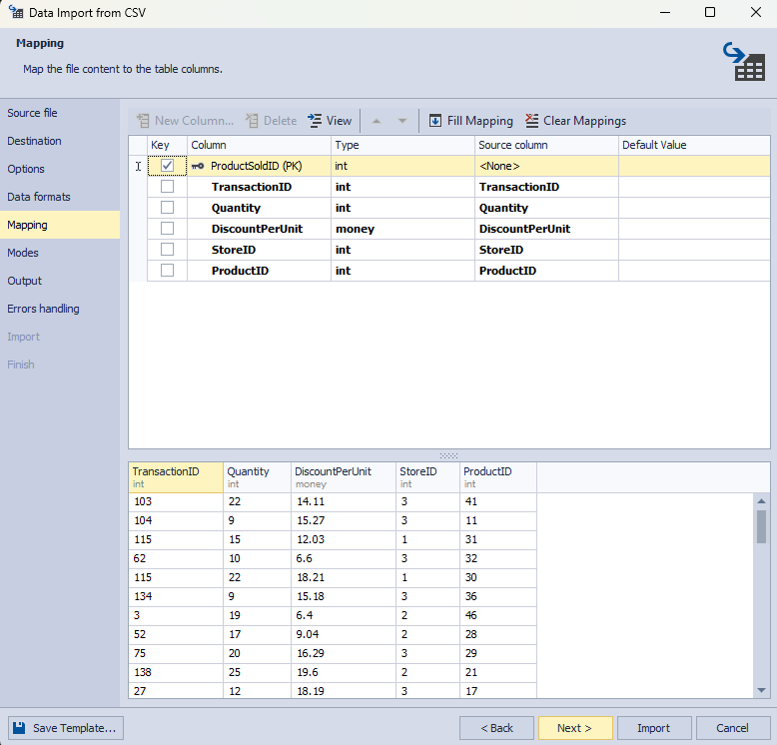

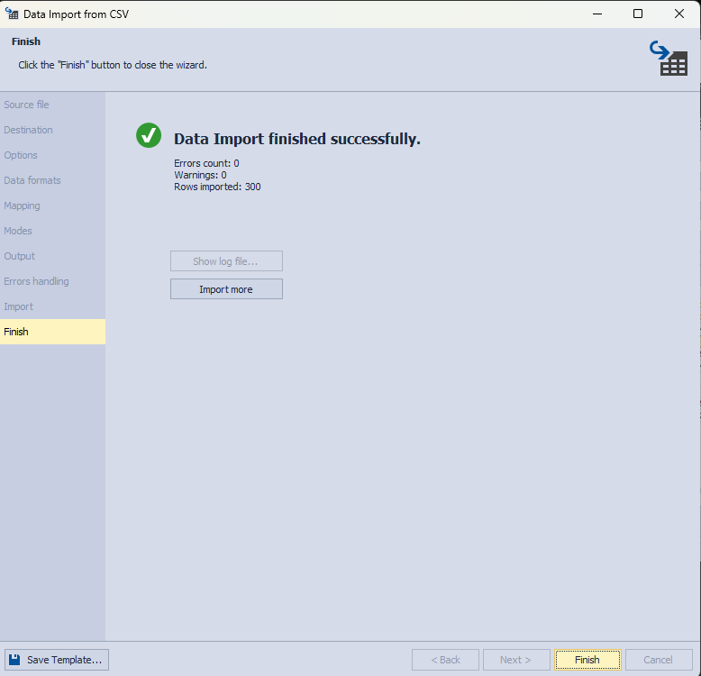

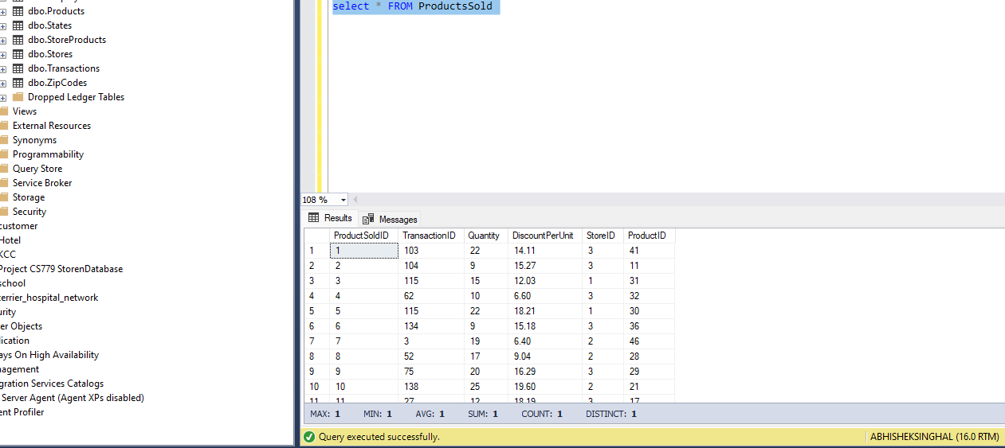

Inserting New Record in Employee table and checking changes in dwEmployeeDim

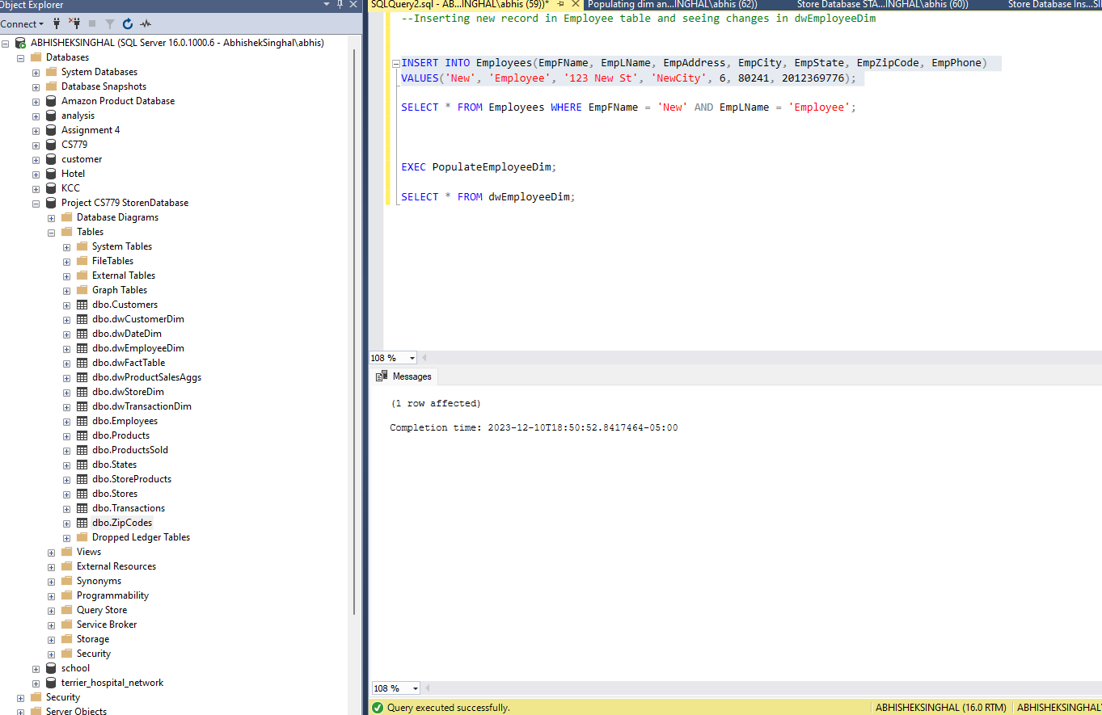

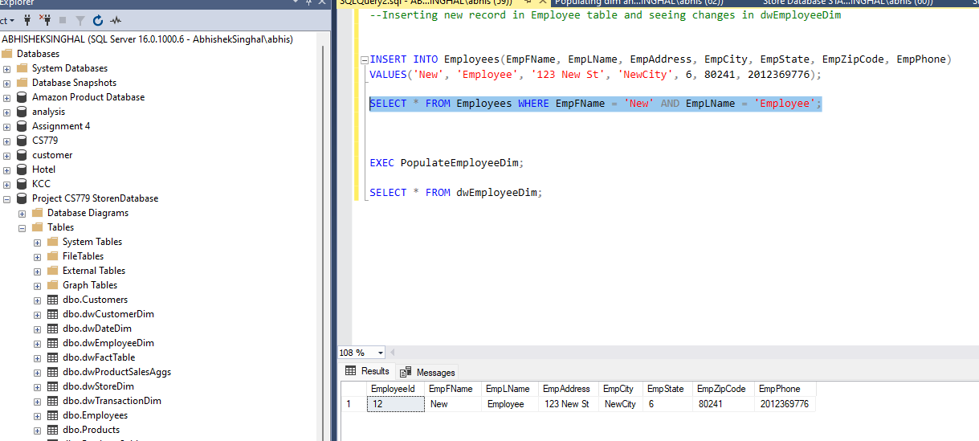

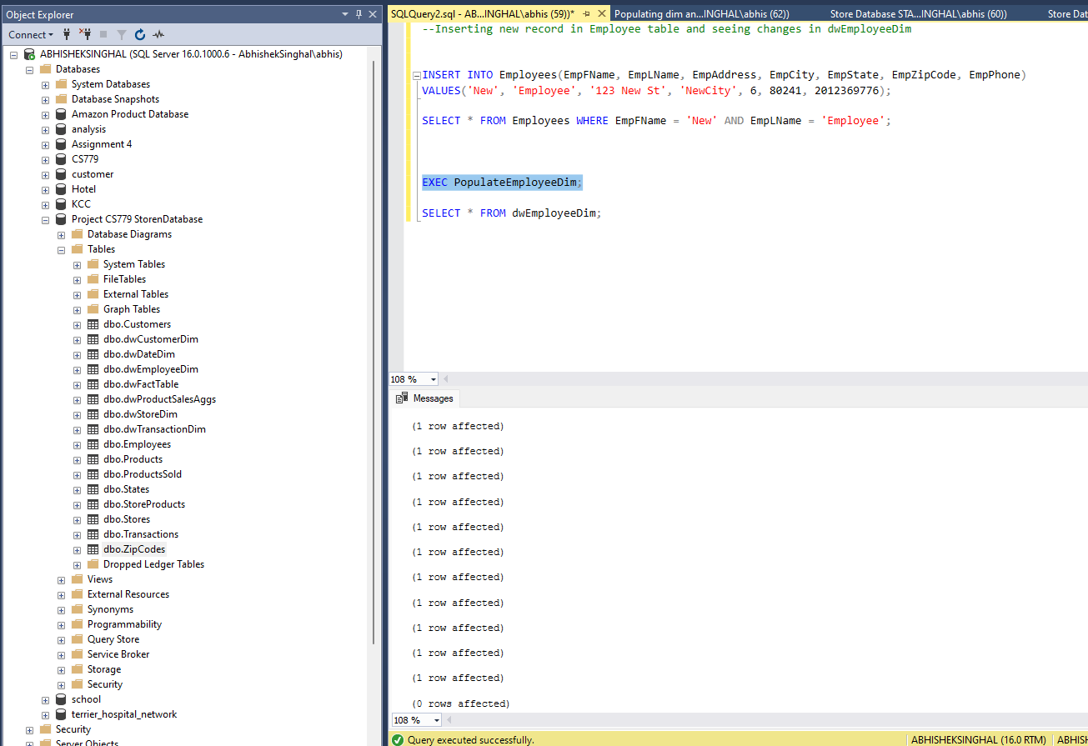

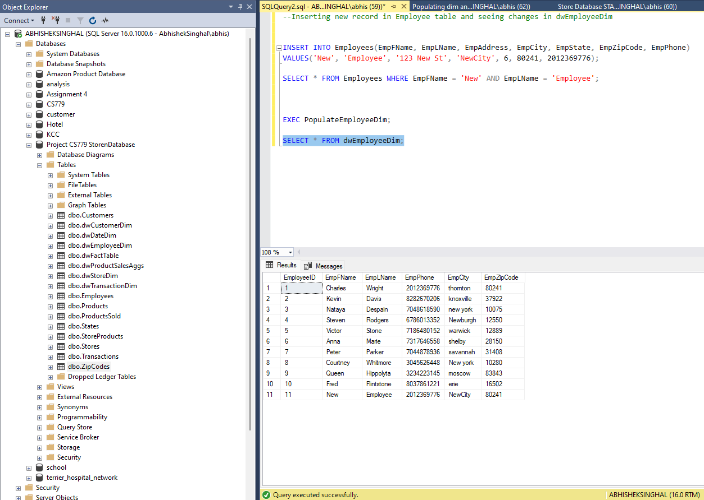

Updating Employee Table and checking changes in dwEmployeeDim

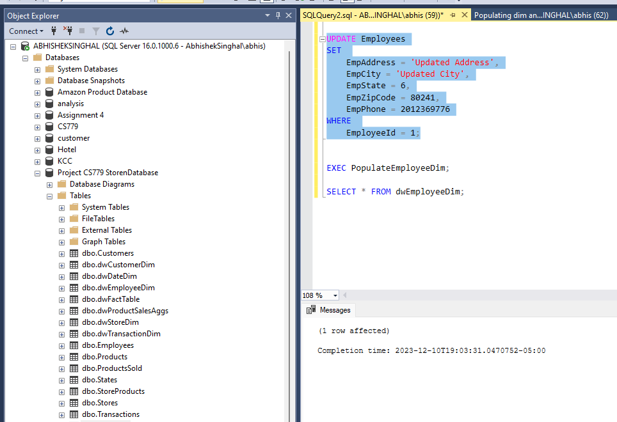

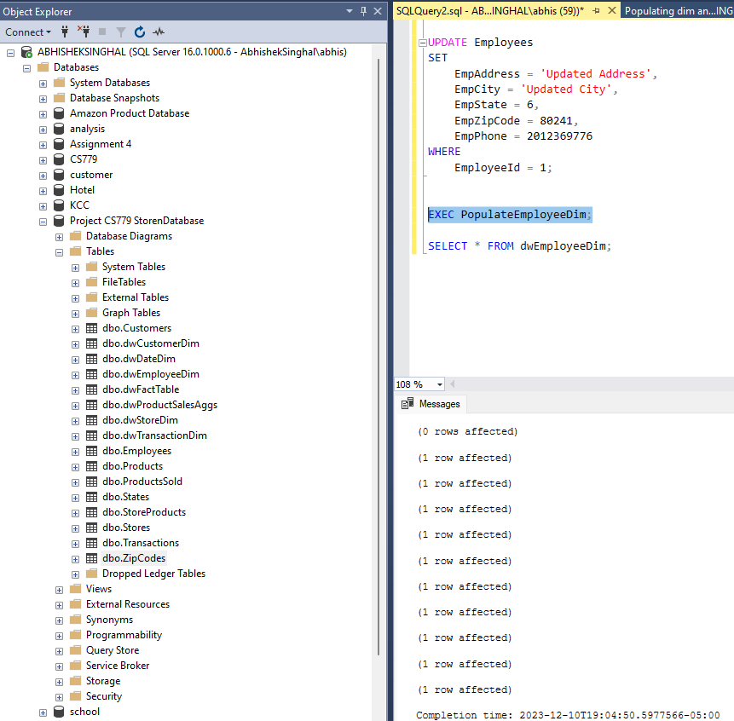

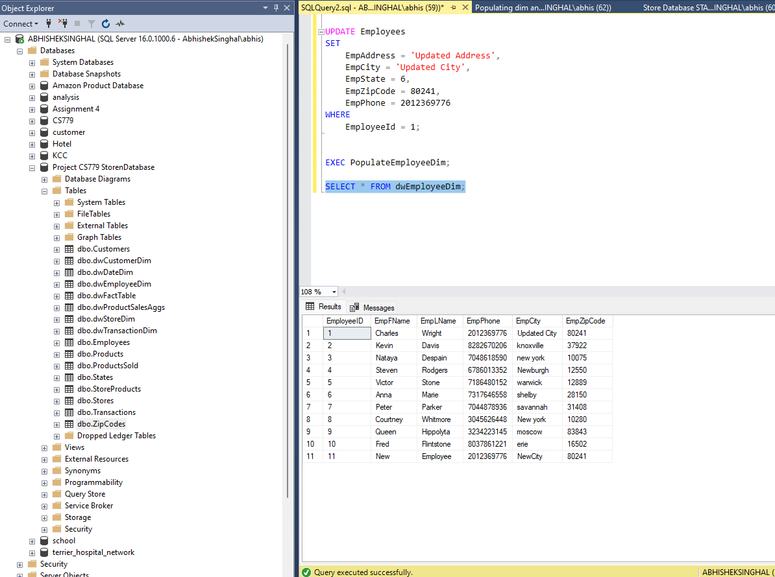

Slow Changing Dimensions

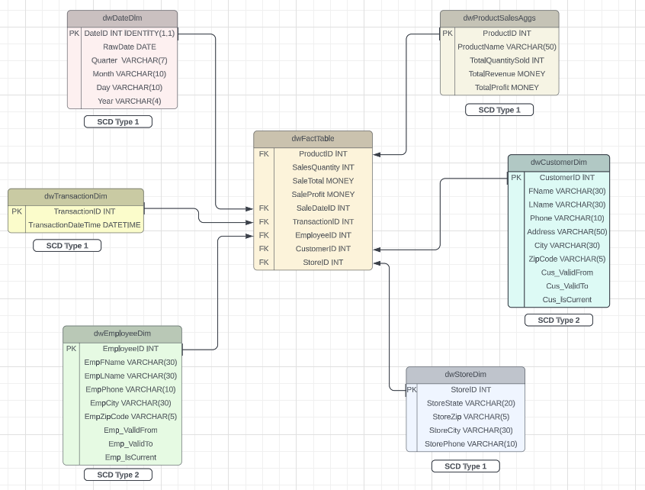

**dwProductSalesAggs (Product Dimension):**

SCD Type: Typically Type 1.

In many cases, product attributes such as product name, total quantity sold, total revenue, and total profit may not change frequently or may not need to be preserved historically. SCD Type 1 suffices when historical changes in product details are not essential for analysis.

**dwEmployeeDim (Employee Dimension):**

SCD Type: Type 2

Employee details such as name, phone, city, and zip code may change over time. Tracking these changes using a Type 2 SCD enables historical analysis, showing how employee details evolved over different periods.

**dwTransactionDim (Transaction Dimension):**

**SCD Type:** Typically Type 1

Transaction details, represented by the transaction dimension, are often considered immutable once recorded. Changes to transaction details may not be relevant for analysis. Therefore, a Type 1 SCD is suitable, updating existing records without preserving historical versions.

**dwCustomerDim (Customer Dimension):**

SCD Type: Type 2

Customer attributes like name, phone, address, city, and zip code can change over time. A Type 2 SCD is valuable in preserving historical information about customers, allowing analysis of how customer details changed over different periods.

**dwDateDim (Date Dimension):**

**SCD Type:** Typically Type 1

Date-related attributes such as quarter, month, day, and year are less likely to change over time. So, Type 1 SCD is sufficient, updating existing records without preserving historical versions, as changes to date attributes are infrequent.

**dwStoreDim (Store Dimension):**

SCD Type: Type 1

If any attribute of a store changes (such as state, zip, city, phone), the existing record in the dwStoreDim is simply updated with the new values. No new records are created to preserve the historical context of changes.

Conclusion

This project is poised to enhance the electronic store's operational efficiency, data quality, and analytical capabilities. By implementing a sophisticated data management system, we aim to empower stakeholders with timely and accurate information, fostering strategic decision-making, and ultimately, driving the success of the electronic retail venture.

Bibliography

* Lucidchart
* **Power BI Microsoft**
* **Study Material provided by Professor.**